**Director Glenn Way Diverts *American Leadership Academy* Properties To His Private Ownership – and Hides the Fact from the State and the I.R.S.**

**Jim Hall**

**Arizonans for Charter School Accountability**

The non-profit American Leadership Academy (ALA) was founded by former Utah state legislator Glenn Way in 2009. Since that time, ALA has expanded exponentially with 12 schools and over 5000 students this year and several new schools scheduled for opening in 2017-18. ALA only owns two of the campuses, Mesa ALA and San Tan Valley ALA, because they were financed with bonds that can only be obtained by non-profit charter schools. The rest of the schools are either directly owned by Way and his associates or leased by Way and then rented back to ALA.

More alarming, ALA has submitted deceptive and inaccurate information hiding the fact that Way profits tremendously on ALA real estate transactions. ALA has not reported their relationship with Glenn Way’s real estate development firm, Schoolhouse Development LLC, on reports required by the State - the annual financial report and their annual audit and has filed incomplete and inaccurate I.R.S. 990 returns in 2014 and 2015.

Glenn Way is a businessman and his business is charter school development. He owns a company in Salt Lake City, Schoolhouse Development LLC, with two partners, Scott and Corey Brand. Schoolhouse Development LLC provides all aspects of charter school facilities development including data analysis, financing, architectural design, and construction.[[1]](#footnote-1) They have completed over 20 charter construction projects, including five ALA schools.[[2]](#footnote-2)

Instead of hiring Schoolhouse Development to assist in building their facilities, ALA turns over the entire ownership of the facilities to Schoolhouse Development and then leases the facilities back from Schoolhouse. As a result, Glenn Way and his partners become the owners of all of the property and buildings while collecting untold fees for building the schools. ALA signs its life away with each lease, pledging that all revenue coming to the school will go first to pay the mortgage on the property – Glenn Way’s mortgage.

ALA recently was in the news because the Town of Gilbert allowed ALA to build a school on 42 acres near Loop 202 and Higley Road after discouraging Higley Unified School District from building a school there last year.[[3]](#footnote-3)

**How Glenn Way will profit from the new ALA school on Higley and Loop 202**

**Step 1.** Glenn Way formed a new for-profit real estate company, Schoolhouse Higley LLC. (SHH). SHH is owned by the following entities:[[4]](#footnote-4)

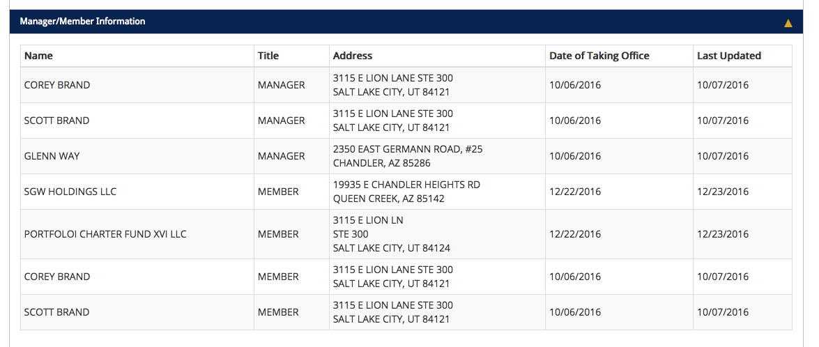

SGW Holdings LLC is owned by Glenn Way and his wife Shelina:[[5]](#footnote-5)

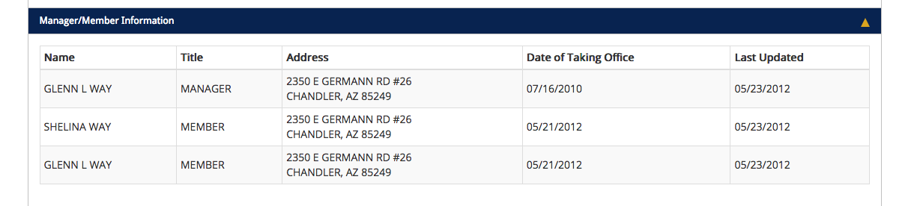

Portfolio Charter Fund XVI LLC is a Salt Lake company owned by Scott and Corey Brand:[[6]](#footnote-6)

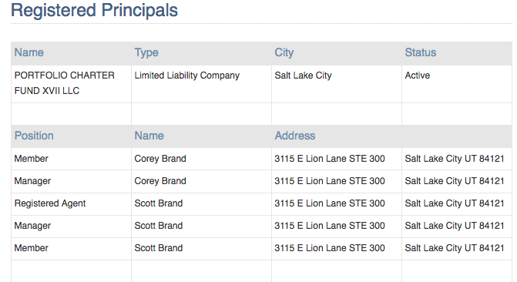

**Step 2.** The new company, Schoolhouse Higley, then secured a construction loan for $36 million from a mortgage trust in Canada, Romspen Mortgage Limited Partnership:[[7]](#footnote-7)

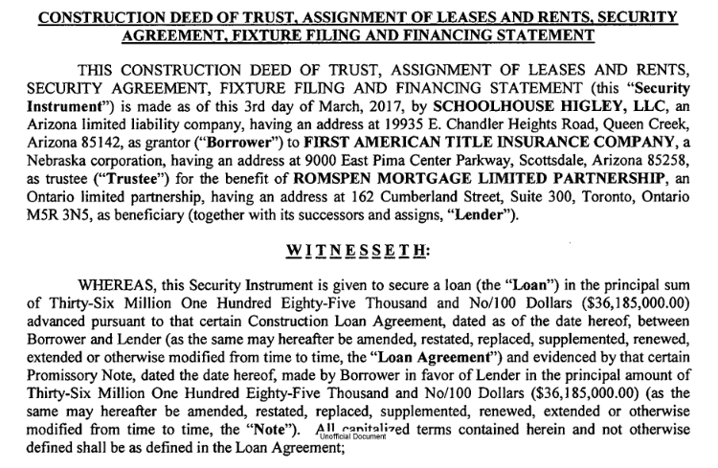

**Step 3.** Schoolhouse Higley qualified for the $36 million loan by signing a **subordination agreement** with ALA. ALA agreed to lease the property from Schoolhouse Higley and pledged that all rent will go toward the mortgage. This gives the lender a guarantee that all of the state revenue collected by ALA will go to paying the mortgage before any other expenses are paid. [[8]](#footnote-8) See below:

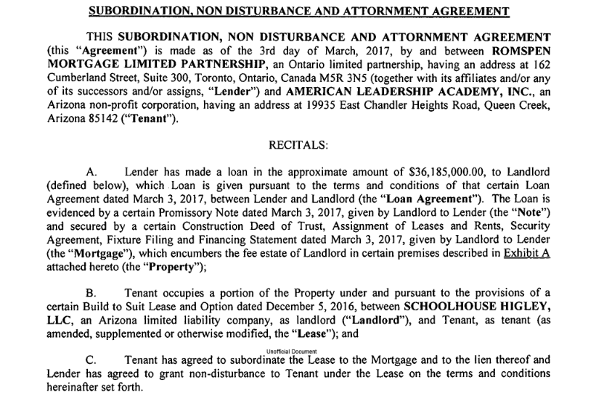

**The Result?** Glenn Way, his wife, and partners in Salt Lake have access to $36 million to build a school for ALA and can pay themselves an unknown amount for development fees, planning, and construction. Since ALA has a waiver from the Arizona Charter Board from following Arizona procurement laws, there are no open bids and no records of how much was spent for the purchase price of the 42 acres, the construction contract, or fees to Glenn Way and his associates. When the school is completed, Way and the Brand brothers will own 42 acres and a $30+ million facility. The non-profit ALA will own …zip, but will have a huge lease payments to support Glenn Way’s mortgage. Lease payments paid for by Arizona taxpayers.

Ironwood ALA, Mesa ALA, and Anthem ALA have similar arrangements where Way and the Brands charged fees to build the schools and now hold the deeds to the properties and buildings while leasing the schools back to ALA.

Two other ALA properties, Queen Creek ALA and Gilbert ALA, were financed by Education Capitol Solutions (ECS), a subsidiary of EPR Properties, one of the largest charter financing companies in the U.S.[[9]](#footnote-9) Education Capitol Solutions has ownership of the two ALA schools and leases them to ALA. But instead of leasing the Queen Creek and Gilbert campuses directly to ALA, ECS leases the schools to Schoolhouse Development. Schoolhouse then leases the schools to ALA for an unknown markup – all benefiting Glenn Way and the Brand brothers.

This type of self-dealing between a for-profit company and a non-profit charter school that have common ownership allows complete secrecy because the operations of the for-profit company are not privy to public scrutiny. Never the less, non-profit 501(3)(C) charter schools must at least report these “related party” transactions.

ALA completely fails to do so and even has failed to report over $4 million in rent expenses paid to Schoolhouse Development on their 2015 annual financial report.

**ALA’s failure to report related party transactions:**

**1. ALA annual audits**

ALA reported renting buildings and property on all audits between 2012 -2016. Rent increased from $1,162,928 in 2012 to $7,880,357 in 2016. ALA never acknowledges that it is paying rent to ALA Director Glenn Way’s company. See below.[[10]](#footnote-10)

*NOTE 9 - RENT*

*The School rents buildings and property. For the fiscal year ended June 30, 2016 total rent paid was $7,880,357.*

**2. ALA Annual Financial Report 2015**

ALA reported that they paid $4,129,362 in rent to an undisclosed source on their 2015 audit. They did not report this expenditure on their 2015 annual financial report in the Operation & Maintenance of Plant line, or any other line of the report.[[11]](#footnote-11) See below:

|  |  |  |  |  |
| --- | --- | --- | --- | --- |
| **CHARTER SCHOOL** | American Leadership Academy |  | **CTDS NUMBER** | 078725000 |
|  | [Macintosh HD:Users:newowner:Library:Caches:TemporaryItems:msoclip:0:clip_image001.png](#RANGE!ExpensesPage2)   |  | | --- | |  | | Totals | | % Increase/ Decrease in Actual |
| [**Expenses**](#RANGE!ExpensesPage2) |  |  | Prior Year |
| **1000 Schoolwide Project** | | **Actual** | Actual |
| **100 Regular Education** | | 7,813,923 | 5,973,521 | 30.81% |
| 1000 Instruction |  |
| 2000 Support Services | | 483,467 | 469,892 | 2.89% |
| 2100 Students |  |
| 2200 Instruction |  | 0 | 0 | 0.00% |
| 2300 General Administration | | 2,297,662 | 1,778,717 | 29.18% |
| 2400 School Administration | | 2,289,349 | 1,712,926 | 33.65% |
| 2500 Central Services | | 0 | 0 | 0.00% |
| **2600 Operation & Maintenance of Plant** | | **636,104** | **0** | **--** |
| 2900 Other Support Services | | 0 | 0 | 0.00% |
| 3000 Operation of Noninstructional Services | | 231,095 | 501,002 | -53.87% |
| 4000 Facilities Acquisition & Construction | | 0 | 0 | 0.00% |
| **5000 Debt Service** |  | **1,963,961** | **5,689,483** | -65.48% |
| 610 School-Sponsored Cocurricular Activities | | 0 | 0 | 0.00% |
| 620 School-Sponsored Athletics | | 0 | 0 | 0.00% |
| 630, 700, 800, 900 Other Programs | | 0 | 0 | 0.00% |
| Subtotal (lines 1-14) |  | 15,715,561 | 16,125,541 | -2.54% |

ALA has falsely listed rent expenses as “Debt Service” in other annual financial reports (note the $5,689,483 above in the Prior Year Debt Service line). While their rent payments are being used for the “debt service” of Schoolhouse Development loans, they are not debt service for ALA.

**3. Incomplete and inaccurate I.R.S. 990 returns**

Most disturbing is the failure of ALA to disclose required information on their annual IRS 990 return. ALA answered “No” to this question on their 2014-15 return, even though they pay mortgages owned by their Director.[[12]](#footnote-12)

*Was the organization a party to a business transaction with one of the following parties? (see Schedule L, Part IV instructions for applicable filing thresholds, conditions, and exceptions)*

* *An entity of which a current or former officer,director,trustee,or key employee(or a family member thereof)was an officer, director, trustee, or direct or indirect owner? If "Yes,"complete Schedule L, Part IV . .*

ALA paid their Director’s for-profit company over $4 million in lease payments in 2015 and did not provide that information to the I.R.S. as required.

ALA also failed to itemize its expenses as required by the IRS. We have never seen a 990 form where the non-profit simply stated the total expenses with breaking down the expenditures – such things as salaries, management fees, lobbying, etc. This is the Statement of Functional Expenses from the ALA 2014-15 990:[[13]](#footnote-13)

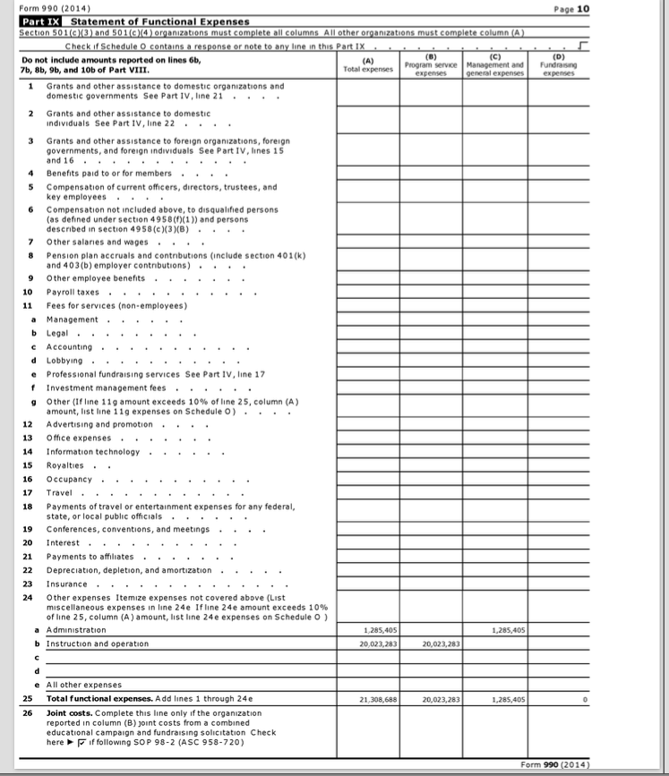

A formal complaint is being filed with the IRS regarding this deliberate omission and the false reporting of related party transactions.

**4. Confusion over what is owned by ALA and what is owned by their Director’s company, Schoolhouse Development**

ALA decided to list all of the capitol leases it has with Schoolhouse as assets in 2015 on both their audit and 990 form – over $90 million. In 2016 ALA retracted the leases as assets on their audit. [[14]](#footnote-14)

They listed their rent payments to Schoolhouse Development as “debt service” on their annual financial reports. They have a hard time deciding if the assets are Glenn Way’s or ALA’s.

There is no confusion. Four ALA campuses are the private assets of Glenn Way and his associates. Mr. Way profits immensely by providing the financing, planning, and construction of ALA schools and then retains the property and buildings as personal assets, not assets of the non-profit charter he directs.

ALA takes every opportunity to hide their business relationship with their Director and have been successful at doing so because of the complete lack of supervision and oversight at both the State and Federal level. Apparently no one at the Arizona Department of Education, the Arizona State Board for Charter Schools, or even the Internal Revenue Service checks to make sure reports are completed properly, let alone monitors them for compliance.

We hope that will soon change.

1. http://www.schooldev.net/services [↑](#footnote-ref-1)
2. http://www.schooldev.net/projects [↑](#footnote-ref-2)
3. http://www.azcentral.com/story/news/local/gilbert/2016/12/21/gilbert-and-higley-districts-criticize-town-over-charter-school-plan/95498290/ [↑](#footnote-ref-3)
4. http://ecorp.azcc.gov/Details/Corp?corpId=L21286568 [↑](#footnote-ref-4)
5. ecorp.azcc.gov/Details/Corp?corpId=L16156326 [↑](#footnote-ref-5)
6. https://secure.utah.gov/bes/principalInfo.html [↑](#footnote-ref-6)
7. https://recorder.maricopa.gov/UnOfficialDocs2/pdf/20170155361.pdf [↑](#footnote-ref-7)
8. https://recorder.maricopa.gov/UnOfficialDocs2/pdf/20170155364.pdf [↑](#footnote-ref-8)
9. http://www.eprkc.com/portfolio-overview/public-charter-schools/ [↑](#footnote-ref-9)
10. 2016 annual audit available at http://online.asbcs.az.gov/charterholders/search/results?corporate\_name=American+Leadership+academy&entity\_id=&ctds= [↑](#footnote-ref-10)
11. 2015 Annual Financial Report at https://www.ade.az.gov/Budget/SubmittedFileStatus/SubmittedFileStatus.asp?NS=True&DR=5&FY=2015&TVR=11-3054&RPP=1&PC=&Subm=True&btnSubmit=++++Go%21++++ [↑](#footnote-ref-11)
12. 2014-15 ALA 990 p. 4 [↑](#footnote-ref-12)
13. I.R.S. ALA 990 2015 available at: https://projects.propublica.org/nonprofits/organizations/810625000 [↑](#footnote-ref-13)
14. 2015 and 2016 ALA Audits at http://online.asbcs.az.gov/charterholders/search/results?corporate\_name=American+Leadership+academy&entity\_id=&ctds= [↑](#footnote-ref-14)