Why We Must Demand Charter Accountability: Part 2
Alternative Charters Are A Path To Riches
Seventy percent of charters spending the least on classroom instruction are Alternative Schools
Arizonans for Charter School Accountability
Jim Hall

Educators, politicians, and parents would all agree that tax funds should be spent primarily in the classroom on teachers, teacher aides, and classroom supplies. There are 20 charter holders in the state, however, that put almost no money in the classroom – they spend most of their revenue on management and real estate. Fourteen of these pathetic charter schools are alternative schools. Six are managed by one of the largest charter holders in the state, the Leona Group.

Enrollment | Charter Holder | Type | Admin/Pupil | Facilities/pupil | Instruction/pupil | Admin More than Instruction | Facilities More than Instruction
 | State Average |  | $1,786 | $1,730 | $3,625
525 | Academy of Math and Science South, Inc. |  | $2,434 | $3,412 | $2,011 | $424 | $1,401
156 | AIBT-NON PROFIT CHARTER SCHOOL | ALT | $703 | $2,672 | $675 | $28 | $1,997
334 | American Charter Schools Foundation Alta Vista | ALT | $2,732 | $2,894 | $2,123 | $608 | $770
139 | American Charter Schools Foundation Desert Hills | ALT | $3,402 | $4,673 | $3,307 | $95 | $1,366
188 | American Charter Schools Foundation Estrella | ALT | $2,669 | $3,507 | $1,835 | $834 | $1,672
394 | American Charter Schools Foundation South Pointe | ALT | $2,337 | $2,982 | $1,482 | $855 | $1,500
384 | American Charter Schools Foundation West Phoenix | ALT | $2,070 | $2,674 | $1,582 | $488 | $1,093
632 | E-Institute Charter Schools, Inc | ALT | $3,561 | $2,241 | $1,993 | $1,569 | $249
13 | East Valley Academy |  | $1,569 | $2,059 | $0 | $1,569 | $2,059
179 | The Griffin Foundation, The |  | $2,845 | $2,765 | $2,417 | $428 | $349
87 | IntelliSchool Charter High School | ALT | $4,763 | $1,418 | $1,139 | $3,625 | $280
61 | Kaizen Vista Grove Middle | ALT | $2,327 | $1,917 | $1,889 | $438 | $28
114 | Legacy Education Group | ALT | $3,123 | $4,782 | $2,617 | $506 | $2,164
29 | Lifelong Learning Research Institute Inc. | ALT | $2,976 | $5,895 | $2,924 | $51 | $2,970
305 | Paramount Education Studies Inc |  | $3,086 | $1,498 | $1,493 | $1,593 | $5
161 | PAS Charter Inc. | ALT | $5,704 | $1,720 | $1,279 | $4,425 | $441
126 | Pima Prevention Partnership Arizona Collegiate High School |  | $2,606 | $2,089 | $1,913 | $692 | $176
55 | SC Jensen Corporation | ALT | $6,387 | $1,735 | $1,688 | $4,700 | $47
33 | Victory High School, Inc. |  | $1,680 | $1,689 | $1,393 | $286 | $295
24 | Vista Charter | ALT | $5,054 | $3,050 | $344 | $4,710 | $2,706

Alternative schools serve the most at-risk students in the state – students with histories of disruption, returning dropouts, students more than a year behind in credits, primary care givers, adjudicated, and foster kids. Alternative schools primarily serve minority students – 91% of alternative charter schools have a higher minority population than the average charter school. Alternative charters are only in session 144 days per year instead of the standard 180 days, yet receive the same funding as regular charter schools. There are no A-F grades for alternative charter schools, so they have no academic accountability – Arizona State Board for Charter Schools (the Charter Board) cannot close alternative schools for academic deficiencies.

Students in alternative schools need an incredible amount of support to be successful – counselors, social workers, tutors, small class sizes, caring teachers, and an engaging curriculum. You would think it would be more expensive to educate students that couldn’t make it in regular schools, but instead, most alternative charter schools have limited facilities and fewer teachers and support staff than regular schools. As a result, alternative charter schools are making millions for many of their owners.

Summary:
Of 75 alternative charter schools in Arizona:
- 20 lost money in 2018
  - Half of these still spent more for administration or facilities per pupil than the average charter school.
  - 9 of the overspending charters spent more on BOTH administration and facilities than the state average.
- 30 spent less than 90% of their revenue, collectively banking $15 million (the state average is 96% of revenue spent).
  - 17 of these spent more on administration than state averages.
  - 14 spent more on facilities than state averages.
  - 10 spent more on both administration and buildings than state averages.
  - 22 of the 30 spent less on classroom instruction than the state average …while they left $15million unspent to add to their assets.
- 49 spent more on administration per pupil than the state charter average
- 41 spent more on facilities per pupil than the state average
- 22 spent more on administration per pupil than on classroom instruction
- 29 spent more per pupil on facilities than on classroom instruction
- 14 spent more on BOTH administration and facilities per pupil than on classroom instruction

This report will look at alternative charter school spending for 2018 and compare spending with state charter averages. 2018 Annual Financial Reports were compiled and October 1 Enrollment Reports were used to determine enrollment. Compiled data is available at azcsa.org.

Losing money while spending more on administration and buildings
Twenty alternative charter schools spent more than their revenue in 2018. You would think there would be some serious belt-tightening when you are losing money. Not here. Three quarters of the schools losing money spent more on administration and facilities and less in the classroom than state averages.

Of the 20 alternative charter schools that lost money in 2018:
- 14 spent more than the average of $1,786/pupil on administration
- 15 spent more than the average of $1,730/pupil for facilities
- 9 spent more on BOTH administration and facilities than the state average
- 14 spent less than the state average of $3,625 for classroom instruction

2018 alternative charter schools losing money based on per pupil spending compared to state charter averages
Enrollment | Charter Holder | Total Revenue | Total M&O | Net | Administration/Pupil Red= More than $1,786 Average | Facilities/pupil Red = More than $1,730 average | Instruction/pupil Red = Less than $3,625 average
265 | SRPMIC COMMUNITY SCHOOLS | $5,129,085 | $6,566,989 | ($1,437,904) | $3,739 | $0 | $8,419
166 | Vector School District, Inc | $1,672,513 | $2,135,934 | ($463,421) | $1,584 | $5,161 | $3,526
139 | American Charter Schools Foundation Desert Hills | $1,685,278 | $2,141,269 | ($455,991) | $3,402 | $4,673 | $3,307
188 | South Valley Academy, Inc. | $1,773,010 | $2,159,872 | ($386,862) | $1,684 | $3,700 | $2,943
232 | South Phoenix Academy, Inc. | $2,385,654 | $2,700,153 | ($314,499) | $1,231 | $5,127 | $2,641
257 | Southwest Leadership Academy | $2,880,257 | $3,114,852 | ($234,595) | $2,824 | $2,226 | $3,472
127 | AZ Compass Schools, Inc | $2,456,175 | $2,582,028 | ($125,853) | $1,630 | $9,905 | $5,067
195 | The Edge School Inc | $2,041,638 | $2,161,857 | ($120,219) | $1,381 | $2,295 | $3,439
98 | Academy with Community Partners, Inc. | $1,108,396 | $1,194,885 | ($86,489) | $2,514 | $4,300 | $3,139
127 | Skyline Gila River Schools, LLC | $2,494,550 | $2,576,509 | ($81,959) | $4,923 | $3,686 | $5,919
175 | Cornerstone Charter School, Inc. | $1,719,910 | $1,786,617 | ($66,707) | $3,378 | $1,917 | $2,783
56 | Liberty High School | $795,393 | $846,774 | ($51,381) | $5,433 | $1,208 | $6,085
131 | Skyline Schools, Inc | $2,147,886 | $2,192,669 | ($44,783) | $2,249 | $585 | $3,162
118 | TUCSON PREPARATORY SCHOOL | $1,221,535 | $1,258,793 | ($37,258) | $2,280 | $1,968 | $2,458
112 | The Phoenix School of Academic Excellence | $1,133,343 | $1,163,658 | ($30,315) | $2,431 | $2,973 | $2,583
82 | Yuma Private Industry Council dba Ed Opportunity Center | $1,038,815 | $1,065,751 | ($26,936) | $3,526 | $912 | $5,221
134 | Southern Arizona Community Academy, Inc. | $1,479,087 | $1,493,053 | ($13,966) | $3,044 | $819 | $6,694
110 | Kaizen Skyview | $1,397,106 | $1,403,924 | ($6,818) | $2,355 | $4,092 | $3,533
124 | RSD Charter School | $713,387 | $717,671 | ($4,284) | $722 | $2,209 | $1,183
24 | Vista Charter | $215,056 | $217,766 | ($2,710) | $5,054 | $3,050 | $344

Putting money in the bank rather than spending it on at-risk students
Near half of all alternative charters (30) spent less than 90% of their revenue, increasing their bottom line by $15 million. These charter owners could not think of additional services or programs that might bolster student achievement for the most challenging students in the state – so they increased their assets by $15 million rather than spending it on students.

Many of the schools losing money spent more on administration and facilities and less in the classroom than state averages:
- 17 spent more than the average of $1,786/pupil on administration
- 14 spent more than the average of $1,730/pupil for facilities
- 10 spent more on BOTH administration and facilities than the state average - 4 are managed by the Leona Group
- 22 spent less than the state average of $3,625/pupil for classroom instruction

2018 alternative charters spending less than 90% of revenue - expenditures/pupil for administration, facilities, and instruction
Enrollment | Charter Holder | Total Revenue | Total M&O | Net | % Revenue | Admin/Pupil Red= more than $1,786 Average | Facilities/pupil Red = More than $1,730 average | Instruction/pupil Red = Less than $3,625 average
139 | Accelerated Learning Center, Inc. | $1,635,807 | $1,284,749 | $351,058 | 79% | $2,862 | $2,315 | $3,463
89 | Ha:San Educational Services | $1,705,408 | $1,359,127 | $346,281 | 80% | $2,764 | $2,308 | $3,127
634 | Career Success | $5,648,431 | $4,980,624 | $667,807 | 88% | $1,751 | $2,504 | $1,757
39 | Career Development, Inc. | $746,229 | $647,430 | $98,799 | 87% | $3,320 | $2,038 | $3,969
94 | Genesis Academy | $1,004,650 | $895,869 | $108,781 | 89% | $2,943 | $890 | $4,551
114 | Legacy Education Group | $1,729,113 | $1,463,054 | $266,059 | 85% | $3,123 | $4,782 | $2,617
329 | NORTH STAR CHARTER SCHOOL, INC. | $3,805,030 | $3,235,984 | $569,046 | 85% | $1,586 | $931 | $6,288
334 | American Charter Schools Foundation Alta Vista | $4,450,817 | $3,656,132 | $794,685 | 82% | $2,732 | $2,894 | $2,123
361 | American Charter Schools Foundation Peoria | $4,243,073 | $3,709,558 | $533,515 | 87% | $2,187 | $2,443 | $2,695
394 | American Charter Schools Foundation South Pointe | $4,255,769 | $3,748,929 | $506,840 | 88% | $2,337 | $2,982 | $1,482
400 | Kaizen El Dorado High school | $3,778,677 | $3,319,311 | $459,366 | 88% | $2,309 | $1,321 | $2,303
363 | Kaizen Maya High | $3,778,065 | $3,181,399 | $596,666 | 84% | $2,226 | $1,533 | $2,234
240 | Kaizen South Pointe El | $2,527,172 | $2,100,084 | $427,088 | 83% | $1,673 | $1,788 | $2,025
263 | Kaizen Summit | $2,619,771 | $2,218,369 | $401,402 | 85% | $1,789 | $1,614 | $2,313
61 | Kaizen Vista Grove Middle | $697,623 | $576,087 | $121,536 | 83% | $2,327 | $1,917 | $1,889
387 | Blueprint Education, Inc. | $3,614,632 | $2,994,099 | $620,533 | 83% | $1,812 | $1,157 | $2,169
988 | GAR, LLC | $7,576,507 | $6,325,771 | $1,250,736 | 83% | $1,723 | $397 | $2,830
13 | Pinnacle Education-Kino Academy, Inc. | $674,937 | $434,334 | $240,603 | 64% | $6,637 | $992 | $11,091
512 | Pinnacle Education-Tempe, Inc | $6,353,782 | $3,112,338 | $3,241,444 | 49% | $840 | $1,834 | $1,116
165 | Pinnacle Education-Westmark Chandler Boulevard, Inc | $1,055,481 | $188,913 | $866,568 | 18% | $85 | $495 | $168
181 | Canyon Rose Academy, Inc. | $2,491,059 | $2,166,333 | $324,726 | 87% | $2,236 | $1,851 | $6,116
150 | Desert Rose Academy, Inc. | $1,455,555 | $1,208,135 | $247,420 | 83% | $1,678 | $1,113 | $4,114
222 | Mountain Rose Academy, Inc. | $2,311,346 | $2,002,005 | $309,341 | 87% | $1,577 | $1,425 | $4,707
258 | Pima Rose Academy, Inc. | $2,980,621 | $2,587,127 | $393,494 | 87% | $1,761 | $1,457 | $5,274
469 | Southgate Academy, Inc | $5,607,369 | $4,374,494 | $1,232,875 | 78% | $1,788 | $1,617 | $2,969
156 | AIBT-NON PROFIT CHARTER SCHOOL | $1,472,950 | $1,146,549 | $326,401 | 78% | $703 | $2,672 | $675
639 | Educational Options Foundation | $5,120,329 | $2,340,977 | $2,779,352 | 46% | $281 | $719 | $1,620
93 | James Sandoval Preparatory High School Crown Pointe | $817,254 | $417,681 | $399,573 | 51% | $1,482 | $1,001 | $1,160
24 | Kestrel Schools, Inc. | $275,256 | $160,610 | $114,646 | 58% | $1,545 | $1,150 | $1,179
90 | Pace Preparatory Academy, Inc. | $977,550 | $837,403 | $140,147 | 86% | $2,300 | $2,622 | $2,673

High Administrative costs
49 of 75 Alternative Charter schools spent more on administration than the state average. These schools averaged over $1,200/pupil more for administration than the average charter school in Arizona. Six charter holders spent over $3,000/pupil more than the average. If these schools expended the state average $1,786/pupil for administration, they would have saved $11,798,461 that could have been used to help students.

2018 alternative charters spending more than the state average ($1,786/pupil) for administration
Enrollment | Charter Holder | Admin/Pupil more than $1,786 Average | More than Average | Additional spending over average
134 | Southern Arizona Community Academy, Inc. | $3,044 | $1,258 | $168,609
139 | Accelerated Learning Center, Inc. | $2,862 | $1,076 | $149,598
82 | Yuma Private Industry Council dba Ed Opportunity Center | $3,526 | $1,740 | $142,713
1541 | Ombudsman Educational Services, Ltd. | $2,323 | $537 | $826,862
24 | Vista Charter | $5,054 | $3,268 | $78,438
265 | SRPMIC COMMUNITY SCHOOLS | $3,739 | $1,953 | $517,420
56 | Liberty High School | $5,433 | $3,647 | $204,238
3891 | American Virtual Academy | $2,459 | $673 | $2,618,350
161 | PAS Charter Inc. | $5,704 | $3,918 | $630,839
55 | SC Jensen Corporation | $6,387 | $4,601 | $253,081
175 | Cornerstone Charter School, Inc. | $3,378 | $1,592 | $278,600
87 | IntelliSchool Charter High School | $4,763 | $2,977 | $259,006
89 | Ha:San Educational Services | $2,764 | $978 | $87,020
270 | Compass High School, Inc. | $3,607 | $1,821 | $491,668
112 | The Phoenix School of Academic Excellence | $2,431 | $645 | $72,249
39 | Career Development, Inc. | $3,320 | $1,534 | $59,841
94 | Genesis Academy | $2,943 | $1,157 | $108,715
114 | Legacy Education Group | $3,123 | $1,337 | $152,455
334 | American Charter Schools Foundation Alta Vista | $2,732 | $946 | $315,887
117 | American Charter Schools Foundation Apache Trails | $3,357 | $1,571 | $183,757
226 | American Charter Schools Foundation Crestview | $2,089 | $303 | $68,471
139 | American Charter Schools Foundation Desert Hills | $3,402 | $1,616 | $224,681
188 | American Charter Schools Foundation Estrella | $2,669 | $883 | $165,990
361 | American Charter Schools Foundation Peoria | $2,187 | $401 | $144,582
394 | American Charter Schools Foundation South Pointe | $2,337 | $551 | $217,118
381 | American Charter Schools Foundation Sun Valley | $2,133 | $347 | $132,206
384 | American Charter Schools Foundation West Phoenix | $2,070 | $284 | $109,034
400 | Kaizen El Dorado High school | $2,309 | $523 | $209,137
363 | Kaizen Maya High | $2,226 | $440 | $159,876
110 | Kaizen Skyview | $2,355 | $569 | $62,609
128 | Kaizen South Pointe Jr Hi | $2,586 | $800 | $102,336
263 | Kaizen Summit | $1,789 | $3 | $736
59 | Kaizen Tempe Accelerated | $2,115 | $329 | $19,407
214 | Kaizen Vista Grove | $2,276 | $490 | $104,765
61 | Kaizen Vista Grove Middle | $2,327 | $541 | $33,014
257 | Southwest Leadership Academy | $2,824 | $1,038 | $266,832
98 | Academy with Community Partners, Inc. | $2,514 | $728 | $71,360
387 | Blueprint Education, Inc. | $1,812 | $26 | $10,204
29 | Lifelong Learning Research Institute Inc. | $2,976 | $1,190 | $34,499
13 | Pinnacle Education-Kino Academy, Inc. | $6,637 | $4,851 | $63,062
127 | Skyline Gila River Schools, LLC | $4,923 | $3,137 | $398,347
131 | Skyline Schools, Inc | $2,249 | $463 | $60,636
36 | Pillar Charter School | $2,456 | $670 | $24,137
181 | Canyon Rose Academy, Inc. | $2,236 | $450 | $81,402
149 | Arizona Call A Teen Youth Resources, Inc | $3,178 | $1,392 | $207,434
469 | Southgate Academy, Inc | $1,788 | $2 | $876
118 | TUCSON PREPARATORY SCHOOL | $2,280 | $494 | $58,284
632 | E-Institute Charter Schools, Inc | $3,561 | $1,775 | $1,121,845
90 | Pace Preparatory Academy, Inc. | $2,300 | $514 | $46,235
 |  |  | Total | $11,798,461

More administration spending than in the classroom
Twenty-two alternative charters spent more per pupil on administration than on classroom instruction. This included 9 Leona Group schools, 2 owned by David Curd, and 3 owned by Steve Durand:

2018 alternative charters spending more on administration than classroom instruction
Owner | Charter Holder | Admin/Pupil | Instruction/pupil | Administration more than instruction
Steve Durand | AIBT-NON PROFIT CHARTER SCHOOL | $703 | $675 | $28
Leona Group | American Charter Schools Foundation Alta Vista | $2,732 | $2,123 | $608
Leona Group | American Charter Schools Foundation Apache Trails | $3,357 | $3,068 | $289
Leona Group | American Charter Schools Foundation Desert Hills | $3,402 | $3,307 | $95
Leona Group | American Charter Schools Foundation Estrella | $2,669 | $1,835 | $834
Leona Group | American Charter Schools Foundation South Pointe | $2,337 | $1,482 | $855
Leona Group | American Charter Schools Foundation West Phoenix | $2,070 | $1,582 | $488
Sharlet Barnett, Lori McClennan | Arizona Call A Teen Youth Resources, Inc | $3,178 | $1,798 | $1,381
John Kerk, and Michael Ferguson | Compass High School, Inc. | $3,607 | $2,875 | $732
George Smith | Cornerstone Charter School, Inc. | $3,378 | $2,783 | $595
Timothy Smith | E-Institute Charter Schools, Inc | $3,561 | $1,993 | $1,569
David Curd | IntelliSchool Charter High School | $4,763 | $1,139 | $3,625
Steven Durand | James Sandoval Preparatory High School Crown Pointe | $1,482 | $1,160 | $322
Leona Group | Kaizen El Dorado High school | $2,309 | $2,303 | $6
Leona Group | Kaizen South Pointe Jr Hi | $2,586 | $2,185 | $401
Leona Group | Kaizen Vista Grove Middle | $2,327 | $1,889 | $438
Steven Durand | Kestrel Schools, Inc. | $1,545 | $1,179 | $366
Kathy Tolman | Legacy Education Group | $3,123 | $2,617 | $506
Mary Lou Klem | Lifelong Learning Research Institute Inc. | $2,976 | $2,924 | $51
David Curd | PAS Charter Inc. | $5,704 | $1,279 | $4,425
David Curd | SC Jensen Corporation | $6,387 | $1,688 | $4,700
Caroline White | Vista Charter | $5,054 | $344 | $4,710

High facilities costs
Facilities costs, unlike administrative or classroom expenses, are fixed – you have to pay the mortgage or lease regardless of enrollment and revenue. 41 out of 75 alternative charters spent more than the state average of $1,730/pupil for facilities. These schools averaged $1,357/pupil more for facilities than the average charter school in Arizona. If these schools expended the state average of $1,786/pupil for administration, they would have saved $9,361,103.

Enrollment | Charter Holder | Facilities/pupil More than $1,730 average | More than average | Additional Cost
98 | Academy with Community Partners, Inc. | $4,300 | $2,570 | $251,846
139 | Accelerated Learning Center, Inc. | $2,315 | $585 | $81,329
156 | AIBT-NON PROFIT CHARTER SCHOOL | $2,672 | $942 | $146,990
334 | American Charter Schools Foundation Alta Vista | $2,894 | $1,164 | $388,735
117 | American Charter Schools Foundation Apache Trails | $2,045 | $315 | $36,887
226 | American Charter Schools Foundation Crestview | $2,741 | $1,011 | $228,587
139 | American Charter Schools Foundation Desert Hills | $4,673 | $2,943 | $409,042
188 | American Charter Schools Foundation Estrella | $3,507 | $1,777 | $334,055
361 | American Charter Schools Foundation Peoria | $2,443 | $713 | $257,343
394 | American Charter Schools Foundation South Pointe | $2,982 | $1,252 | $493,343
381 | American Charter Schools Foundation Sun Valley | $2,750 | $1,020 | $388,728
384 | American Charter Schools Foundation West Phoenix | $2,674 | $944 | $362,681
127 | AZ Compass Schools, Inc | $9,905 | $8,175 | $1,038,200
181 | Canyon Rose Academy, Inc. | $1,851 | $121 | $21,970
39 | Career Development, Inc. | $2,038 | $308 | $11,993
634 | Career Success | $2,504 | $774 | $490,892
270 | Compass High School, Inc. | $2,734 | $1,004 | $271,211
175 | Cornerstone Charter School, Inc. | $1,917 | $187 | $32,783
632 | E-Institute Charter Schools, Inc | $2,241 | $511 | $323,105
195 | The Edge School Inc | $2,295 | $565 | $110,228
89 | Ha:San Educational Services | $2,308 | $578 | $51,470
110 | Kaizen Skyview | $4,092 | $2,362 | $259,847
240 | Kaizen South Pointe El | $1,788 | $58 | $13,909
59 | Kaizen Tempe Accelerated | $3,028 | $1,298 | $76,557
214 | Kaizen Vista Grove | $1,894 | $164 | $35,173
61 | Kaizen Vista Grove Middle | $1,917 | $187 | $11,427
114 | Legacy Education Group | $4,782 | $3,052 | $347,879
29 | Lifelong Learning Research Institute Inc. | $5,895 | $4,165 | $120,781
90 | Pace Preparatory Academy, Inc. | $2,622 | $892 | $80,278
112 | The Phoenix School of Academic Excellence | $2,973 | $1,243 | $139,177
512 | Pinnacle Education-Tempe, Inc | $1,834 | $104 | $53,046
196 | Premier Charter High School | $3,098 | $1,368 | $268,178
124 | RSD Charter School | $2,209 | $479 | $59,342
55 | SC Jensen Corporation | $1,735 | $5 | $251
127 | Skyline Gila River Schools, LLC | $3,686 | $1,956 | $248,374
232 | South Phoenix Academy, Inc. | $5,127 | $3,397 | $788,146
188 | South Valley Academy, Inc. | $3,700 | $1,970 | $370,451
257 | Southwest Leadership Academy | $2,226 | $496 | $127,494
118 | TUCSON PREPARATORY SCHOOL | $1,968 | $238 | $28,078
166 | Vector School District, Inc | $5,161 | $3,431 | $569,609
24 | Vista Charter | $3,050 | $1,320 | $31,688
 |  |  | Total | $9,361,103

More facilities spending than in the classroom
Real estate seems to be the most important thing at many alternative schools. 29 alternative charters spent more on facilities per pupil than on classroom instruction – 10 are managed by the Leona Group, three are owned by David Curd, and three are owned by Rhonda Owens, George Weihling, and Swenford Anderson.

2018 alternative charters spending more per pupil on facilities than on instruction
Owner | Enrollment | Charter Holder | Facilities/pupil | Instruction/pupil | Facilities more than instruction
Cynthia Johnson Aaron Herres | 98 | Academy with Community Partners, Inc. | $4,300 | $3,139 | $1,161
Steve Durand | 156 | AIBT-NON PROFIT CHARTER SCHOOL | $2,672 | $675 | $1,997
Leona -Theodore Frederick,Michele Kaye | 334 | American Charter Schools Foundation Alta Vista | $2,894 | $2,123 | $770
Leona -Theodore Frederick,Michele Kaye | 226 | American Charter Schools Foundation Crestview | $2,741 | $2,203 | $538
Leona -Theodore Frederick,Michele Kaye | 139 | American Charter Schools Foundation Desert Hills | $4,673 | $3,307 | $1,366
Leona -Theodore Frederick,Michele Kaye | 188 | American Charter Schools Foundation Estrella | $3,507 | $1,835 | $1,672
Leona -Theodore Frederick,Michele Kaye | 394 | American Charter Schools Foundation South Pointe | $2,982 | $1,482 | $1,500
Leona -Theodore Frederick,Michele Kaye | 381 | American Charter Schools Foundation Sun Valley | $2,750 | $2,405 | $345
Leona -Theodore Frederick,Michele Kaye | 384 | American Charter Schools Foundation West Phoenix | $2,674 | $1,582 | $1,093
Rhonda Owens | 127 | AZ Compass Schools, Inc | $9,905 | $5,067 | $4,838
Jean Duffy | 634 | Career Success | $2,504 | $1,757 | $748
Timothy Smith | 632 | E-Institute Charter Schools, Inc | $2,241 | $1,993 | $249
David Curd | 87 | IntelliSchool Charter High School | $1,418 | $1,139 | $280
Leona -Theodore Frederick,Michele Kaye | 110 | Kaizen Skyview | $4,092 | $3,533 | $559
Leona -Theodore Frederick,Michele Kaye | 59 | Kaizen Tempe Accelerated | $3,028 | $2,909 | $119
Leona -Theodore Frederick,Michele Kaye | 61 | Kaizen Vista Grove Middle | $1,917 | $1,889 | $28
Kathy Tolman | 114 | Legacy Education Group | $4,782 | $2,617 | $2,164
Mary Lou Klem | 29 | Lifelong Learning Research Institute Inc. | $5,895 | $2,924 | $2,970
David Curd | 161 | PAS Charter Inc. | $1,720 | $1,279 | $441
Pinnacle Education- Muhammad Padela | 512 | Pinnacle Education-Tempe, Inc | $1,834 | $1,116 | $717
Pinnacle Education- Muhammad Padela | 165 | Pinnacle Education-Westmark Chandler Boulevard, Inc | $495 | $168 | $327
Cladia Ramos | 196 | Premier Charter High School | $3,098 | $3,041 | $57
Sandra Davis | 124 | RSD Charter School | $2,209 | $1,183 | $1,026
David Curd | 55 | SC Jensen Corporation | $1,735 | $1,688 | $47
Dawn Livesey | 232 | South Phoenix Academy, Inc. | $5,127 | $2,641 | $2,486
Rhonda Owens, George Weihling, S Anderson | 188 | South Valley Academy, Inc. | $3,700 | $2,943 | $758
Julie and Nate Palma | 112 | The Phoenix School of Academic Excellence | $2,973 | $2,583 | $389
Rhonda Owens, George Weihling, S Anderson | 166 | Vector School District, Inc | $5,161 | $3,526 | $1,635
Caroline White | 24 | Vista Charter | $3,050 | $344 | $2,706

Fourteen of the worst charter schools in Arizona are alternative schools
Fourteen alternative charters spent more per pupil on BOTH administration and facilities per pupil than on classroom instruction – six are managed by the Leona Group and three are owned by David Curd.

Owner | Enrollment | Charter Holder | Administration/Pupil | Facilities/Pupil | Instruction/pupil | Admin More Than Instruction | Facilities More Than Instruction
Caroline White | 24 | Vista Charter | $5,054 | $3,050 | $344 | $4,710 | $2,706
David Curd | 161 | PAS Charter Inc. | $5,704 | $1,720 | $1,279 | $4,425 | $441
David Curd | 55 | SC Jensen Corporation | $6,387 | $1,735 | $1,688 | $4,700 | $47
David Curd | 87 | IntelliSchool Charter High School | $4,763 | $1,418 | $1,139 | $3,625 | $280
Kathy Tolman | 114 | Legacy Education Group | $3,123 | $4,782 | $2,617 | $506 | $2,164
Leona -Theodore Frederick,Michele Kaye | 334 | American Charter Schools Foundation Alta Vista | $2,732 | $2,894 | $2,123 | $608 | $770
Leona -Theodore Frederick,Michele Kaye | 139 | American Charter Schools Foundation Desert Hills | $3,402 | $4,673 | $3,307 | $95 | $1,366
Leona -Theodore Frederick,Michele Kaye | 188 | American Charter Schools Foundation Estrella | $2,669 | $3,507 | $1,835 | $834 | $1,672
Leona -Theodore Frederick,Michele Kaye | 394 | American Charter Schools Foundation South Pointe | $2,337 | $2,982 | $1,482 | $855 | $1,500
Leona -Theodore Frederick,Michele Kaye | 384 | American Charter Schools Foundation West Phoenix | $2,070 | $2,674 | $1,582 | $488 | $1,093
Leona -Theodore Frederick,Michele Kaye | 61 | Kaizen Vista Grove Middle | $2,327 | $1,917 | $1,889 | $438 | $28
Mary Lou Klem | 29 | Lifelong Learning Research Institute Inc. | $2,976 | $5,895 | $2,924 | $51 | $2,970
Steve Durand | 156 | AIBT-NON PROFIT CHARTER SCHOOL | $703 | $2,672 | $675 | $28 | $1,997
Timothy Smith | 632 | E-Institute Charter Schools, Inc | $3,561 | $2,241 | $1,993 | $1,569 | $249

Conclusions:
The reason alternative charter schools can spend so little on classroom instruction is simple – they are worlds apart from traditional district high schools yet receive $1,770-$2,000 more per pupil from the state than a district school. The storefront charter schools you see in strip malls are likely alternative charter schools. This is the online alternative charter school e-Institute Metro.

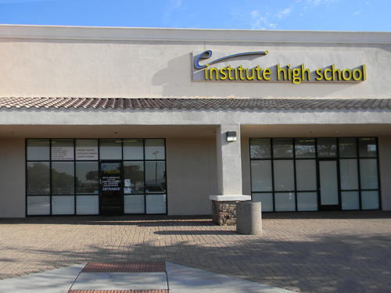

Moon Valley High School, just down the road from e-Institute Metro, receives $2,000 less per pupil in state education funds than e-Institute. Their facilities look like this:

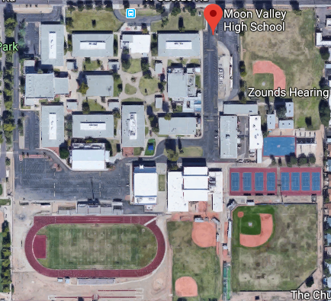

Do you see any profit potential here?

Even the brick and mortar, non-online alternative charter schools have limited programs and few teachers. This is the staff at the Leona Group-managed South Point High School, enrollment 394 students:
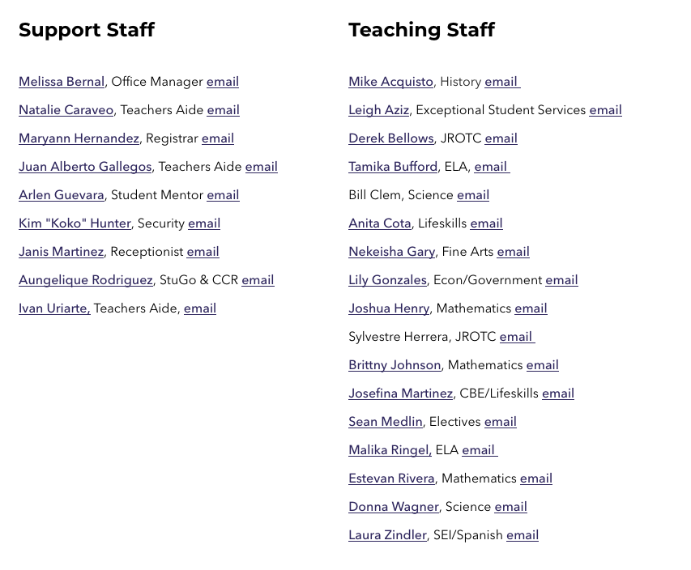

Compare the staff list from a district high school of the same enrollment - Thatcher High School (Thatcher, AZ) enrollment 400:

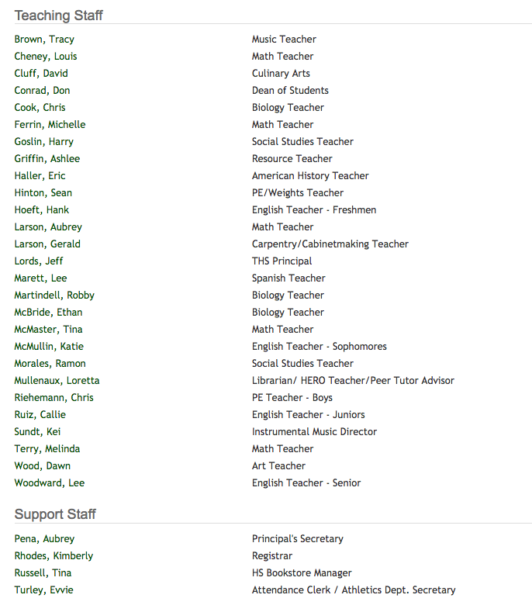

Thatcher has 50% more teachers and offers many more programs – art, band, orchestra, choir, weight training, carpentry, etc. More importantly, Thatcher has twice as many English/Language Arts teachers and math teachers. Thatcher has a counselor (not shown) and South Pointe does not.

The question is: Do at-risk students that have failed in other academic settings benefit from a school with a stripped down curriculum, fewer teachers, and support staff? Or do owners benefit from not having to pay for better classroom instruction and student support, since no one cares how well students are being educated and schools aren’t being monitored closely based on these decisions? In Arizona the owners win. Big time.

Recommendations:
- The Department of Education needs to finalize A-F grades for alternative schools that measure how effectively they are educating students.
- The Charter Board needs to close alternative charters with low academic achievement.
- The Charter Board should investigate the alternative charters that spend less than 80% of their revenue.
- The Charter Board should investigate the alternative charters that spend more on both administration and facilities than on classroom instruction
- The Legislature needs to:
  - Mandate the Charter Board monitor charter spending and publish charter per pupil expenditures for administration, instruction, student support, facilities, and special education compared to state averages. This would allow the Charter Board to monitor and evaluate alternative charter spending to detect fraud and allow parents to make better school choice decisions.
  - Require a complete study of alternative and online schools to determine if they should receive the same charter additional assistance as charters that offer comprehensive programs and have appropriate school facilities.
  - Give the Charter Board, the Auditor General, and the Attorney General authority to audit the books of any charter owner suspected of misappropriating state funds.

Appendix 1

Alternative charter school 2018 demographics (* = 10 or fewer students)
Charter Holder | Asian | American Indian | African American | Hispanic | White | Pacific Islander | Multi-race-non-Hispanic | Total | % Minority Red = over 62% state average
Academy with Community Partners, Inc. | * | * | * | 66 | 24 | * | * | 98 | 76%
Accelerated Learning Center, Inc. | * | * | * | 23 | 108 | * | * | 139 | 22%
AIBT-NON PROFIT CHARTER SCHOOL | * | * | 28 | 113 | * | * | * | 156 | 90%
American Charter Schools Foundation Alta Vista | * | * | * | 315 | 11 | * | * | 334 | 97%
American Charter Schools Foundation Apache Trails | * | * | * | 22 | 87 | * | * | 115 | 24%
American Charter Schools Foundation Crestview | * | * | 16 | 156 | 43 | * | * | 226 | 81%
American Charter Schools Foundation Desert Hills | * | 17 | 16 | 51 | 52 | * | * | 139 | 63%
American Charter Schools Foundation Estrella | * | * | 22 | 139 | 19 | * | * | 188 | 90%
American Charter Schools Foundation Peoria | * | * | 34 | 235 | 73 | * | * | 361 | 80%
American Charter Schools Foundation South Pointe | * | * | 98 | 269 | 12 | * | * | 394 | 97%
American Charter Schools Foundation Sun Valley | * | 17 | 26 | 218 | 105 | * | * | 380 | 72%
American Charter Schools Foundation West Phoenix | * | * | 14 | 346 | 18 | * | * | 384 | 95%
American Virtual Academy | 51 | 106 | 205 | 1,417 | 1,875 | 18 | 198 | 3,889 | 52%
Arizona Call A Teen Youth Resources, Inc | * | * | 14 | 119 | 13 | * | * | 149 | 91%
AZ Compass Schools, Inc | * | 59 | 18 | 35 | 12 | * | * | 127 | 91%
Blueprint Education, Inc. | * | * | * | 34 | * | * | * | 42 | 90%
Canyon Rose Academy, Inc. | * | * | 16 | 80 | 52 | * | * | 159 | 67%
Career Development, Inc. | * | * | * | * | 30 | * | * | 39 | 23%
Career Success | * | 16 | 74 | 460 | 58 | * | 22 | 633 | 91%
Compass High School, Inc. | * | * | 16 | 106 | 134 | * | * | 269 | 50%
Cornerstone Charter School, Inc. | * | 11 | 33 | 92 | 32 | * | * | 175 | 82%
CPLC Community Schools | * | * | * | 90 | * | * | * | 93 | 97%
Desert Rose Academy, Inc. | * | * | * | 95 | 28 | * | * | 148 | 81%
E-Institute Charter Schools, Inc | * | 14 | 39 | 308 | 237 | * | 29 | 632 | 63%
Eastpointe High School, Inc. | * | 31 | 50 | 225 | 266 | * | 14 | 592 | 55%
The Edge School Inc | * | * | * | 99 | 74 | * | * | 195 | 62%
Educational Options Foundation | * | 19 | 14 | 267 | 316 | * | * | 634 | 50%
GAR, LLC | * | 43 | 130 | 572 | 216 | * | 19 | 987 | 78%
Genesis Academy | * | * | * | 83 | * | * | * | 93 | 90%
Ha:San Educational Services | * | 83 | * | * | * | * | * | 89 | 98%
Humanities and Sciences Academy of the U.S., Inc. | * | 13 | 26 | 112 | 45 | * | 11 | 211 | 79%
IntelliSchool Charter High School | * | * | * | 34 | 45 | * | * | 86 | 48%
International Commerce Secondary Schools, Inc. | * | 20 | 44 | 336 | 42 | * | * | 456 | 91%
James Sandoval Preparatory High School Crown Pointe | * | * | * | 86 | * | * | * | 93 | 93%
Kaizen El Dorado High school | * | 13 | 41 | 291 | 45 | * | * | 400 | 89%
Kaizen Maya High | * | * | 61 | 217 | 60 | * | * | 363 | 83%
Kaizen Skyview | * | * | 13 | 69 | 26 | * | * | 110 | 76%
Kaizen South Pointe El | * | * | 109 | 111 | * | * | 13 | 240 | 82%
Kaizen South Pointe Jr Hi | * | * | 54 | 61 | * | * | * | 128 | 82%
Kaizen Summit | * | * | 27 | 210 | 16 | * | * | 263 | 94%
Kaizen Tempe Accelerated | * | * | * | 51 | * | * | * | 59 | 95%
Kaizen Vista Grove | * | 22 | 26 | 109 | 42 | * | 12 | 214 | 80%
Kaizen Vista Grove Middle | * | * | * | 36 | 11 | * | * | 61 | 82%
Kestrel Schools, Inc. | * | * | * | * | * | * | * | 24 | 80%
Legacy Education Group | * | * | * | 17 | 58 | * | * | 94 | 38%
Liberty High School | * | 18 | * | 17 | 19 | * | * | 55 | 65%
Lifelong Learning Research Institute Inc. | * | * | * | 18 | * | * | * | 29 | 80%
Mountain Rose Academy, Inc. | * | * | * | 102 | 106 | * | * | 222 | 52%
NORTH STAR CHARTER SCHOOL, INC. | * | 18 | 31 | 197 | 74 | * | * | 329 | 78%
Nosotros Academy | * | * | * | 184 | 15 | * | * | 211 | 93%
Ombudsman Educational Services, Ltd. | * | 156 | 128 | 966 | 268 | * | 12 | 1541 | 83%
Pace Preparatory Academy, Inc. | * | * | * | 23 | 59 | * | * | 90 | 34%
PAS Charter Inc. | * | * | * | 83 | 59 | * | * | 161 | 63%
The Phoenix School of Academic Excellence | * | * | * | 81 | 14 | * | * | 112 | 88%
Pillar Charter School | * | * | * | 22 | * | * | * | 36 | 70%
Pima Rose Academy, Inc. | * | * | * | 239 | * | * | * | 257 | 95%
Pinnacle Education-Kino Academy, Inc. | * | * | * | 12 | * | * | * | 13 | 98%
Pinnacle Education-Tempe, Inc | * | 65 | 41 | 285 | 107 | * | 13 | 512 | 79%
Pinnacle Education-Westmark Chandler Boulevard, Inc | * | * | * | 133 | 17 | * | * | 165 | 90%
PPEP Tec High School | * | 28 | 20 | 643 | 50 | * | * | 752 | 93%
Portable Practical Education Program (PPEP, Inc) | 22 | 94 | 113 | 723 | 1,777 | * | 114 | 3,321 | 46%
Premier Charter High School | * | * | * | 174 | * | * | * | 196 | 95%
RSD Charter School | * | * | * | 52 | 56 | * | * | 124 | 55%
SRPMIC COMMUNITY SCHOOLS | * | 226 | * | 36 | * | * | * | 265 | 98%
SC Jensen Corporation | * | * | * | 32 | 15 | * | * | 55 | 73%
Skyline Gila River Schools, LLC | * | 126 | * | * | * | * | * | 127 | 100%
Skyline Schools, Inc | * | * | 36 | 67 | 14 | * | * | 131 | 89%
South Phoenix Academy, Inc. | * | * | 83 | 108 | 20 | * | * | 232 | 91%
South Valley Academy, Inc. | * | * | 67 | 97 | 13 | * | * | 187 | 93%
Southern Arizona Community Academy, Inc. | * | * | * | 73 | 36 | * | * | 134 | 73%
Southgate Academy, Inc | * | 34 | * | 401 | 18 | * | * | 469 | 96%
Southwest Leadership Academy | * | * | 19 | 223 | * | * | * | 257 | 92%
TUCSON PREPARATORY SCHOOL | * | * | * | 73 | 27 | * | * | 118 | 77%
Tucson Youth Development, Inc./ACE Charter High School | * | 12 | 23 | 293 | 157 | * | * | 491 | 68%
Vector School District, Inc | * | 44 | 23 | 64 | 28 | * | * | 166 | 83%
Vista Charter | * | * | * | 20 | * | * | * | 24 | 95%
Yuma Private Industry Council dba Ed Opportunity Center | * | * | * | 77 | * | * | * | 82 | 95%
Total Hispanic/White does not include schools reporting fewer than 10 students (*) |  |  |  | 13,293 | 7,234 |  |  | 25,525 | 72%

http://www.azed.gov/accountability-research/altschoolapp/
See Appendix 1 for the demographics of all alternative charter schools. Demographic data from 2018 October 1 Enrollment report at : http://www.azed.gov/accountability-research/data/
Revenue data from page 1 and expenditure totals from page 2 of the 2018 Annual Financial Reports at: http://www.ade.az.gov/schoolfinance/forms/leaquery/submittedfiles.aspx
Per pupil data based on the October 1, 2017 Enrollment Report and compiled 2018 AFR data available at azcsa.org
$15 million more than if the schools had spent 96% of their revenue, the average charter amount
Administrative costs are the total of regular education and special education administration codes 2300, 2400, 2500, 2900 from page 2 of the 2018 Annual Financial Reports
Facilities costs are determined by combining Plant Operations 2600 and Debt Service 5000 expenditures from page 2 of the 2018 Annual Financial Reports
Classroom instruction costs determined by combining regular education and special education 1000 Instruction expenditures from page 2 of the 2018 Annual Financial Reports
Leona Group - The American Charter Schools Foundation bought 10 schools from Leona Group owner Bill Coats for $80 million in 2006, netting Coats over $20 million. Unfortunately, enrollment has declined by 25% since then, but the high mortgage payments continue. (Full report at azcsa.org “Past Research”)
https://www.southpointehs.com/
http://ths.thatcherud.org/
Minority percentage estimated for schools with 10 or fewer White students October 1 Enrollment data at: http://www.azed.gov/accountability-research/data/

