The Richest Charter School in Arizona Has The Worst Academic Performance In The State
Primavera Online owner Damian Creamer makes millions while students languish

Arizonans for Charter School Accountability

Summary:
Primavera Online is by far the richest charter school in Arizona. The non-profit Primavera Technical Learning Center amassed over $45,000,000 is assets 2007-2015 by averaging over $6 million a year in profits. Primavera also bought $5 million in real estate during that time period (all cash transactions). Despite being the wealthiest charter in Arizona, Primavera suddenly gave the charter business to their for-profit software provider, the American Virtual Academy (AVA), owned by the President of the Primavera Board, Damian Creamer. The following year AVA made over $10,000,000 in profit and Creamer, as the only stockholder in AVA, took a distribution of $670,000. In 2017 Creamer took a distribution of $8,785,812 from the profits provided by Primavera Online.

Online schools are funded at 95% the rate of traditional charter schools yet they have no facilities, lunch program, transportation, and hire very few teachers to be available for students. The bottom line is online charters cost very little to operate. Their major expense is the licensing of the software used for instruction. As it happens, Damian Creamer’s for-profit AVA provided the software for Primavera Online to the tune of $97,000,000 in licensing fees 2007-2015. Creamer and family members also drew $1,809,000 in salary and benefits from his non-profit before “giving” the lucrative online business to his for-profit company in 2015, a clear violation of IRS non-profit regulations.

In 2017 Creamer collected $21,000,000 in licensing fees and management costs for AVA and personally cashed in stock worth $8.7 million. In comparison, teacher salaries in 2017 were $2,839,053, 6% of total revenue.

(A complete report (including sources) on the financial relationships between Damian Creamer, Primavera Technical Learning Center, and the America Virtual Academy is available at azcsa.org in “Past Research”)

Primavera Online is the largest online charter school in Arizona but has among the worst student achievement of any school in Arizona. Just 17% of Primavera’s full time high school students completed an English class allowing them to take the AzMerit English test and only 10% of students in grades 9-11 completed a math class allowing them to take the AzMerit Math test in 2018. The number of students passing the exams was shocking: out of 3,371 full and part-time students in grades 9 -11 only 139 passed AzMerit English and just 64 passed AzMerit Math.

I. Where are all of the Primavera Students?
The for-profit American Leadership Academy (AVA) still operates under the name Primavera Online. Primavera serves over 25,000 Arizona students every year according to their website:

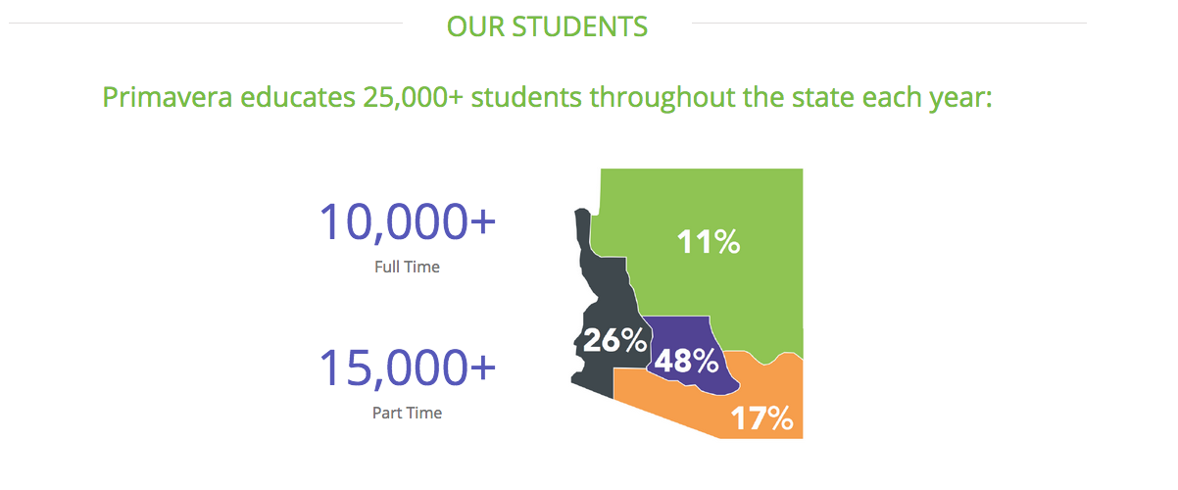
In 2018 AVA was only funded by the state for 5,330 full time and 2,406 part-time students – 7,736 total. That means that over 17,000 of the reported 25,000 students enrolled at AVA in 2018 apparently did not log onto their home computers enough to be considered for funding.

II. Most Primavera Online high school students did not take the AzMerit Test implying that most students were not enrolled in English or math classes
High school students in Arizona are required to pass four English and four math courses to graduate. All charter students in grades 3-11, including online students, have to take the AZMerit test every year. High school students take the AzMerit exam when enrolled in English classes in grade 9-11 and when enrolled in Algebra I, Geometry, and Algebra II. The ADE AzMerit Test manual states:

Students to be Tested
Arizona public school students will test on the AzMERIT End-of-Course (EOC) tests the same semester that the student is expected to complete the course for credit. AzMERIT EOC tests are for students enrolled in courses during the semester that are aligned to the first three English credits required for high school graduation and the first three math credits required for high school graduation. The student’s grade level is not a factor in determining whether or not to participate in AzMERIT EOC testing.

This means that seniors taking lower level courses are required to take the AzMerit test for English., Algebra I&II, and Geometry. It is impossible to tell from the AzMerit data how many 12th grade students took the English and Math tests. Primavera had 1,780 full time and 785 part-time students in grade 12 in 2018 that could have been taking grade 9-11 English classes or the three math classes.

Let’s assume that no seniors took the AzMerit test. Primavera tested just 17% of all full-time students, grades 9-11 in English and only 10% of full-time students in math.

17% of Primavera full time high school students were enrolled in an English class in 2018
Few Primavera high school students were enrolled in required English classes based on the number of students taking the AzMerit English test. Only 17% - 393 out of 2,305 full time students in grades 9-11 took the English test in 2018. Since four years of English is a required for graduation, it is likely that many of the part-time high school students took English classes as well, making the percentage of Primavera enrolled in English classes somewhere between 12% and 17% of the total.

Grade | 9 | 10 | 11 | Total
Full Time ADM | 456 | 787 | 1062 | 2,305
Part-Time ADM | 168 | 342 | 556 | 1066
Total | 624 | 1,129 | 1,618 | 3,371
Number tested ELA | 103 | 133 | 157 | 393
Percent ELA tested all students | 17% | 12% | 10% | 12%
Percent ELA tested Full time Students | 23% | 17% | 10% | 17%

10% 0f Primavera high school students enrolled in math classes in 2018
Math was even more dismal. Only 10% of all full-time Primavera high school students in grades 9-11 were enrolled in Algebra I, Geometry, or Algebra II and took the AzMerit test - 222 students out of 2,305 total. Math, like English, is required of all students in grades 9-11 so it is likely that many part-time students were enrolled in a math class, making the percentage of Primavera students enrolled in a math course 7% to 10% of the total.

Grade | 9 | 10 | 11 | Total
Full Time ADM | 456 | 787 | 1,062 | 2,305
Part-Time ADM | 168 | 342 | 556 | 1,066
Total | 624 | 1,129 | 1,618 | 3,371
Number tested Math | 70 | 80 | 72 | 222
Percent Math tested - all students | 11% | 7% | 4% | 7%
Percent ELA tested - full time students | 15% | 10% | 7% | 10%

What does this mean?
One of two things could be happening. First, it is possible that many more Primavera students were enrolled in English and math classes but are not being tested for some reason. This is a clear violation of state law.

The most likely possibility is that Primavera students simply do not complete the on-line courses they enroll in, so most had dropped the English and math courses before the end of the semester when AzMerit testing was conducted. This doesn’t speak well for the quality of the online programs offered, especially in light of the $97,000,000 in software fees paid to owner Damian Creamer to use his software since 2007. It also brings into question the actual teacher support offered to online students, since Creamer only spends 6% of Primavera’s revenue on teacher salaries.

Who passes the AzMerit Exam at Primavera? Just about no one.
Looking at the raw data, it appears that 30%-40% of Primavera students passed the AzMerit English test. But since so few actually took the test, the reality is that out of the 25,000 students Primavera claims to serve, only 267 students in grades 6-11 passed English. Just 139 high school students passed the AzMerit English exam.

Primavera AzMerit English Results 2018
Grade | 6 | 7 | 8 | 9 | 10 | 11 | Total
Full Time ADM | 35 | 66 | 79 | 456 | 787 | 1,062 | 2,485
Part-Time ADM | 53 | 131 | 263 | 168 | 342 | 556 | 1,513
Total | 88 | 197 | 342 | 624 | 1,129 | 1,618 | 3,998
Number tested ELA | 60 | 123 | 165 | 103 | 133 | 157 | 741
ELA Percent Passing | 32% | 41% | 36% | 41% | 38% | 29%
ELA total number passing | 19 | 50 | 59 | 42 | 51 | 46 | 267

Math results were even worse. Only 132 students out of 3,998 full and part time students, grades 6-11 passed the 2018 AzMerit Math test. 62 Primavera high school students passed an AzMerit math exam. That’s right - just 62 out of 3,371 full and part-time students in grades 9-11 were competent in math.

Primavera AzMerit Math Results 2018
Grade | 6 | 7 | 8 | 9 | 10 | 11 | Total
Full Time ADM | 35 | 66 | 79 | 456 | 787 | 1,062 | 2,485
Part-Time ADM | 53 | 131 | 263 | 168 | 342 | 556 | 1,513
Total | 88 | 197 | 342 | 624 | 1,129 | 1,618 | 3,998
Number tested Math | 61 | 123 | 163 | 70 | 80 | 72 | 569
Percent Passing Math | 16% | 15% | 25% | 30% | 26% | 31%
Total number passing Math | 10 | 18 | 40 | 21 | 21 | 22 | 132

Is it Primavera or Online Instruction in General?
Online instruction faces a number of challenges, the greatest of which is how to get students to turn on the computer and complete the work. A large number of online students have not been successful in traditional settings and many are behind in high school credits.

While online instruction provides a solution, it comes at a cost. Instead of a professional teacher motivating and supervising instruction, online students are often on their own -sitting in their bedroom in front of a computer that is a click away from the Internet, friends, and social media. Teacher phone/email support is available, but do students in this environment raise their hands for help?

There are two other large charter online schools that face the same challenges as Primavera - Arizona Virtual Academy (a part of the nation-wide K-12 chain) and Arizona Connections Academy. Here’s how they compare in the percentage of 9-11 students tested and the percent of all 9-11 students passing the AzMerit ELA and Math tests:

ELA Percent Tested | 9 | 10 | 11 | Total
Primavera | 23% | 17% | 15% | 17%
Arizona Connections Academy | 103% | 92% | 83% | 94%
Arizona Virtual Academy (K-12) | 62% | 43% | 40% | 49%
Math Percent Tested
Primavera | 15% | 10% | 7% | 10%
Arizona Connections Academy | 87% | 64% | 61% | 71%
Arizona Virtual Academy (K-12) | 44% | 41% | 34% | 40%
Percent Full Time Passing ELA
Primavera | 9% | 6% | 4% | 6%
Arizona Connections Academy | 41% | 33% | 31% | 35%
Arizona Virtual Academy (K-12) | 30% | 22% | 14% | 22%
Percent Full Time Passing Math
Primavera | 5% | 3% | 2% | 3%
Arizona Connections Academy | 27% | 24% | 21% | 24%
Arizona Virtual Academy (K-12) | 19% | 14% | 8% | 14%

Arizona Connections Academy tested 94% of all 9-11 students in English and 71% in Math. Arizona Virtual Academy tested 49% in English and 40% in Math – not great, but 3-4 times better than Primavera’s 17% tested in English and 10% tested in Math.

Just 6% of all 9-11 Primavera students passed the ELA test compared to 35% at AZ Connections and 22% at Arizona Virtual Academy. 3% passed the Math test at Primavera while 24% passed at AZ Connections and 14% passed at Arizona Virtual Academy.

There is an achievement gap in online schools that is a nation-wide problem. In Arizona, the achievement gap at Primavera Online is an abyss. Primavera lags far behind the other online charter schools and has the worst performance of any school in the state.

Online charter schools are a problem, Primavera Online is a crisis.

Conclusions:
- Tens of thousands of students that enroll at Primavera Online never complete online courses
- At the most, only 17% of all Primavera high school students were enrolled in an English course in 2018 at the time of testing.
- At the most, only 10% of all Primavera high school students were enrolled in Algebra I, Geometry, or Algebra II in 2018 at the time of testing
- 139 Primavera high school students passed the AzMerit English test 2018 out of a high school population of over 5,000 students
- 62 Primavera high school students passed the AzMerit math test 2018 out of a high school population of over 5,000 students

American Virtual Academy represents the worst example of charter school corruption imaginable. Tens of thousands of students enroll but only 267 learned enough to be competent in English and only 132 passed the AzMerit math exam in grades 6-11. The owner, Damian Creamer, makes millions in profit and bilks taxpayers out of $12-$15 million a year in exorbitant software licensing fees.

What does the Charter Board think of AVA? Creamer’s company has great cash reserves and cash flow - an excellent business…everything is Green to the Charter Board:

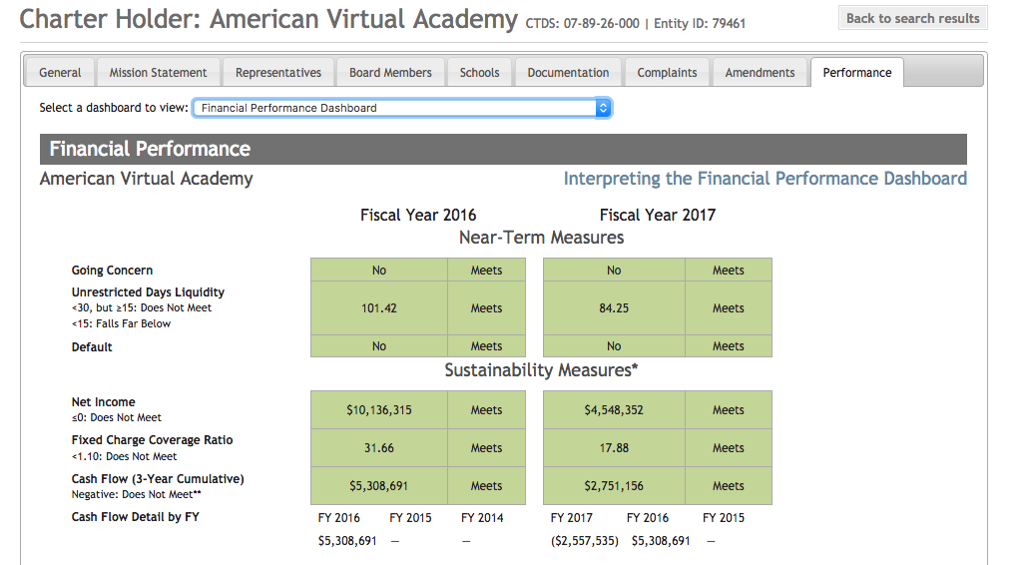

AVA received over $41,000,000 in tax revenue in 2018 and produced less than 400 students able to pass the AzMerit test.

The American Virtual Academy Inc. and the non-profit Primavera Technical Learning Center exist for one reason – to enrich Damian Creamer and his family utilizing tax funds that should have gone to districts and charters that actually educate children.

We say shut them down….

