Arizona Representative Eddie Farnsworth (R) Has Made Millions Owning Charter Schools that Spend More on Their Buildings than in the Classroom
Farnsworth’s Benjamin Franklin Charter Schools are being investigated for Open Meeting Law violations
By
Jim Hall
Arizonans for Charter School Accountability

Eddie Farnsworth has represented District 12 in the Arizona House of Representatives from 2000 -2008 and was re-elected 2012 - present. He was the House Republican Majority Leader in 2003-04. Representative Farnsworth founded one of the first charter schools in Arizona in 1996 – the for-profit Benjamin Franklin Charter School LTD (BFCS). There are now four BFCS schools in the East Valley with a K-12 enrollment of 2950 students.

It is unclear how much Representative Farnsworth makes each year owning BFCS, but he controls millions of dollars in stockholders assets and real estate. Benjamin Franklin Charter Schools is also being investigated by the Attorney General’s Office for open meeting law violations.

Representative Farnsworth profits from charter ownership
It is difficult to ascertain how much Representative Farnsworth profits from his sole ownership of BFCS because for-profit corporations do not have to reveal salary information. We do know that Representative Farnsworth is a multi-millionaire – BFCS has over $3 million in stockholder equity and Farnsworth is the only stockholder. BFCD also has assets of $6.7 million in cash and another $35 million in real estate holdings.

Farnsworth profits from the ownership of his real estate firm LBE Investments LTD (LBE) as well. LBE actually owns each of the BFCS campuses and leases the schools back to BFCS at substantially more than the mortgage payments and property taxes due. See Table 1

Table 1 - BFCS Lease payments compared to LBE
Investment expenses
 | 2013 | 2016
BFCS Lease | $1,554,000 | $4,903,600
LBE Interest | $541,617 | $3,749,229
Salary | $87,000 | $55,192
Benefits | $8,692 | $4,845
Professional Fees | $16,642 | $16,145
Property Taxes | $145,722 | $633,444
Office Fees | $14,859 | $16,059
Total LBE | $814,532 | $4,474,914
Net Gain | $739,468 | $428,686

It is unclear how much of the $428,686 BFCS paid to LBE in addition to the actual real estate costs in 2016 was paid to Farnsworth. It is possible he receives the $55,192 in salaries paid by LBE – there is no way of telling.

Benjamin Franklin Charter School is one of only 63 charter schools in Arizona that spends more on real estate than in the classroom
One hundred and ninety charter holders out of 411 charters in Arizona spent more on classroom instruction than on administration and facilities combined in 2016. But sixty-three charter schools spent more on just their facilities than in the classroom. Benjamin Franklin Charter Schools is on of these, spending $155,106 more on facilities than on all classroom instruction. (Highlighted in red in Table 2)

Table 2 BFCS spending for instruction, administration, and facilities 2011-2016
 | Total Instruction | Total Admin | Total Facilities | Instruction-Facilities | More Admin+Facilities than Instruction
2011 | $4,439,900 | $1,695,925 | $3,613,379 | $826,521 | $869,404
2012 | $4,458,216 | $1,801,349 | $3,605,775 | $852,441 | $948,908
2013 | $4,662,076 | $2,003,560 | $3,509,947 | $1,152,129 | $851,431
2014 | $5,576,849 | $2,119,175 | $5,899,001 | -$322,152 | $2,441,327
2015 | $6,164,760 | $2,159,135 | $6,457,296 | -$292,536 | $2,451,671
2016 | $6,459,495 | $2,177,115 | $6,614,601 | -$155,106 | $2,332,221

Table 2 also indicates the amount BFCS spent on instruction compared to the combination of administrative spending and facilities costs (highlighted in blue), While 190 charter schools spent less on administration and facilities than in the classroom in 2016, BFCS spent $2.3 million more. They have spent more every year since 2011 on administration and facilities than in the classroom. BFCS spent over $2 million less on instruction each of the last three years.

Table 2 also indicates that Farnsworth did spend more in the classroom than on facilities prior to 2014. In 2014 Farnsworth made a major real estate investment that has created huge lease payments to his subsidiary LBE Investments. Facilities costs for BFCS have increased much more than the additional revenue generated by growing enrollment.

Real Estate Purchases
In 2013 there were two BFCS schools serving 2341 students in grades K-8. Farnsworth had a mortgage of $9,000,000 for the facilities and had net assets of $12 million. In 2014, Farnsworth built two new schools and his debt increased to $38 million while his net assets rose to nearly $40 million.

Between 2013 and 2016 enrollment increased by 24% but lease payments went up 298% and overall facilities costs increased 88%. Classroom expenditures rose just 39% in comparison. See Table 3

Table 3 - Enrollment and expenditures 2013 vs. 2016
 | 2013 | 2016 | % Change
Enrollment | 2341 | 2902 | 24%
Schools | 2 | 4
Debt | $9,536,036 | $38,000,513 | 298%
Annual Lease Payments | $1,554,000 | $4,903,600 | 216%
Total Facilities | $3,295,210 | $6,184,090 | 88%
Total Instruction | $4,662,076 | $6,459,495 | 39%
Total Teachers | 97 | 131 | 35%

Large lease payments have taken a toll on Farnsworth’s bottom line. BFCS lost $1.6 million last year and $5.5 million since 2014. (Indicated in bold in Table 4) Farnsworth’s stake in the company, the retained earnings, have declined from $6,404,949 in 2013 to less than half that amount, $3,002,724, in 2016. (Indicated in red in Table 4)

Table 4 - BFCS Cash on hand, Revenue, Expenses, Profit, and Retained Assets 2011-2016
 | 2011 | 2012 | 2013 | 2014 | 2015 | 2016
Enrollment | 2272 | 2304 | 2341 | 2548 | 2850 | 2902
Cash | $4,578,861 | $4,445,904 | $4,578,535 | $5,140,214 | $5,887,178 | $6,713,693
Total Revenue | $12,239,681 | $12,402,016 | $12,888,822 | $15,069,486 | $17,431,600 | $19,088,583
Expenses | $11,161,809 | $11,154,432 | $12,475,401 | $17,118,911 | $19,555,504 | $20,677,479
Profit | $1,077,872 | $1,247,593 | $413,421 | -$2,049,425 | -$2,123,904 | -$1,588,896
Retained assets | $5,401,292 | $6,136,977 | $6,404,949 | $5,250,028 | $4,451,920 | $3,002,724

The income losses have caused BFCS to fail to meet 2 of the six indicators in the Arizona Charter Board’s financial evaluation in 2016. See below:

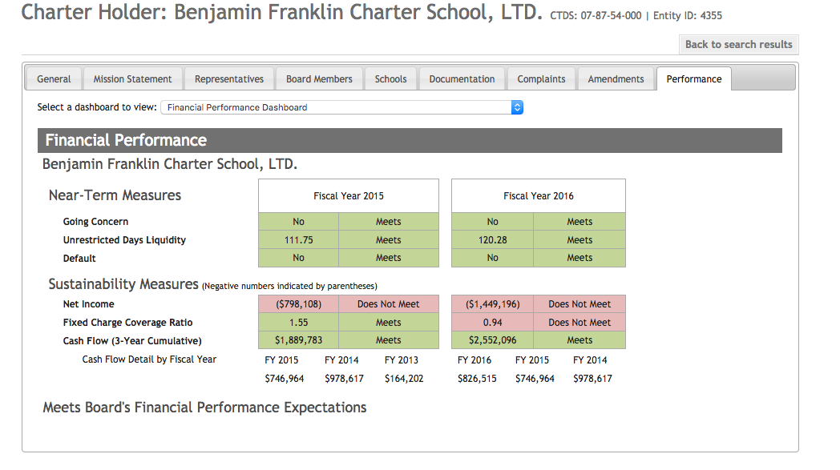

No School Board? No Board Meetings?
A real indication that Benjamin Franklin Charter Schools are controlled by a for-profit corporation is the complete lack of visibility of the BFCS Board. By law, all charter schools must follow Arizona open meeting laws. According to the BFCS audit in 2016, they have information on their website concerning where public notices of Board meetings will be posted – both the physical site and the web location. See below:

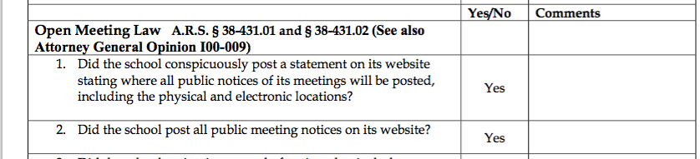

There is, however, nothing on the BFCS website, or any of the schools sites, that gives any information about the Board, where meetings are held, or any future meeting notices. The district and school calendar do not list any Board meetings for the year.

There is a “Notification” tab on the site that lists 3 notifications:

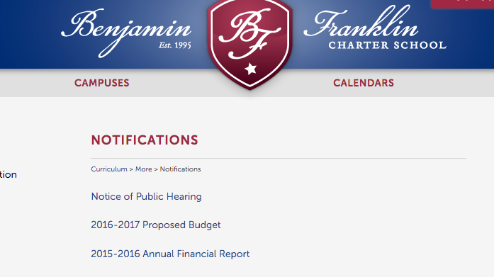

The 2016-17 Proposed budget and the 2015-16 Annual Financial Report links to the documents submitted the State. The notice of public meeting is a notice about a meeting (required by law) on 7/7/16 to approve the proposed budget. There are no further notices available. See the only Board meeting notice below:

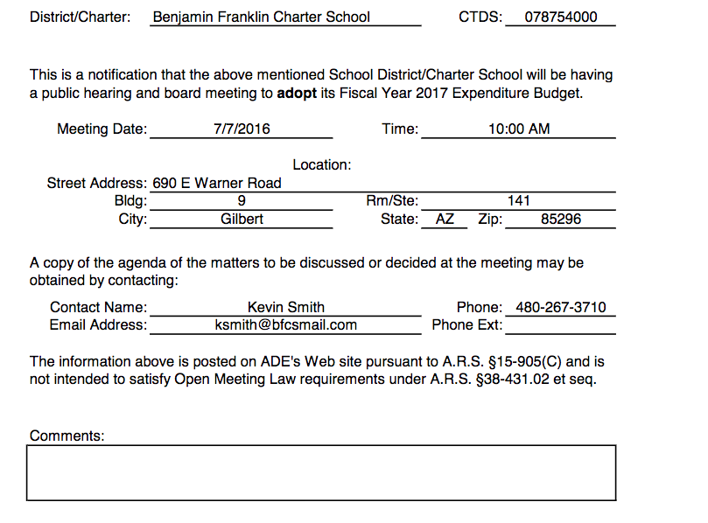

The BFCS website makes no mention of the Board. According to the Arizona Charter Board’s website, Eddie Farnsworth and William Clark are the only Board members. We are unable to determine what William Clark’s relationship is with the schools.

We go to such lengths to document the lack of board presence at BFCS because public participation is a key element of all public schools. Washington State’s Supreme Court outlawed charter schools because they do not have schools boards elected by the public so they may not receive public funds. Representative Farnsworth’s charter school apparently has one meeting a year and keeps Board information secret at BFCS. (See Appendix 2 for the response from the Arizona Ombudsman’s Office regaring the Open Meeting Law complaint we filed on April 3, 2017)

Conclusion:
With the exception of the apparent open meeting law violations, nothing occurring at BFCS is illigal. Charter schools can spend their funds any way they like and no one, even the Arizona Auditor General’s Office, monitors charter spending. In Arizona, all real estate becomes the property of the charter holder, even if the charter goes broke. The free market dictates that the first concern of any company is to its bottom line and Representative Farnsworth has consistantly increased the assets of his schools throughout the years.

It does not seem appropriate, though, for a school to spend more on its buildings than on classroom instruction - all teacher salaries, benefits and classroom supplies. Only 63 charter schools in Arizona spend so much of their budget on real estate at the expense of students and teachers in the classroom.

It certainly questionable that a state legislator that votes on school finance issues is able to profit from charter ownership in this way. If Arizona had greater transparency for charter finances we would know exactly how much Representative Farnsworth profits from his charter ownership. All we know for sure is that it is millions of dollars and that taxpayers are paying his mortgages.

Thanks to Curt Cardine for his valuable data and analysis.
BFCS Annual Financial Report and Audit for 2016 are available at azcsa.org.

Appendix 1.
Definitions of Classroom Instruction, Administration and Facilities Expenses:

Analysis of the data utilized definitions outlined by the Arizona Charter School Unified System of Financial Records (U.S.F.R.) prescribed by the Auditor General for submission of the Annual Financial Report.

Classroom Spending
Classroom spending was determined by combining both regular and special education Instruction 1000 lines from the actual expenditures submitted on the AFR.

1000 INSTRUCTION— Instruction includes the activities dealing directly with the interaction between teachers and students. Teaching may be provided for students in a school classroom, in another location such as a home or hospital, and in other learning situations such as those involving cocurricular activities and school-sponsored athletics. It may also be provided through some other approved medium such as television, radio, computer, Internet, multimedia, telephone, and correspondence that is delivered in side or outside the classroom or in other teacher-student settings. Included here are the activities of aides or classroom assistants of any type (clerks, graders, teaching machines, etc.) that assist in the instructional process.

Administration:
Administrative expenses were determined by combining both regular and special education administrative expenses in three categories as defined by the U.S.F.R.:
General Administration 2300 —Activities concerned with establishing and administering policy for operating the school, including governing board services, executive administration services, and lobbying.
School Administration 2400 —Activities concerned with overall administrative responsibility for a particular campus, including office of the principal services.
Central Services 2500—Activities that support other administrative and instructional functions, including fiscal services; purchasing; warehousing and distributing services; printing, publishing, and duplicating services; planning, research, development, and evaluation services; public information services; personnel services; and administrative technology services.
Facilities Expenses:
Facilities expenses were determined by combining both regular and special education expenditures in two categories:
Operation and Maintenance of Plant 2600—Activities concerned with keeping the physical plant open, comfortable, and safe for use, and keeping the grounds, buildings, and equipment in effective working condition and state of repair. This function includes activities related to operating and maintaining buildings; care and upkeep of grounds; care and upkeep of equipment; vehicle operation and maintenance (other than student transportation vehicles); security; and safety.
This function is also where charter schools report lease payments for the use of buildings
Many charter schools borrow money in the form of tax-free bonds sponsored by government Industrial Authorities to finance the purchase or construction of school facilities. Payments on the mortgage for facilities are reported in the Debt Service function
DEBT SERVICE 5000—Activities related to servicing the long-term debt of the school including payments of both principal and interest.

Appendix 2
Email received April 4, 2016 from the Arizona Ombudsman’s Office:
Mr. Hall,
My name is Danee Garone, and I handle open meeting law matters for the Ombudsman’s office. We received your complaint concerning the Benjamin Franklin Charter School. You said,
The Benjamin Franklin Charter School does not include information on their website (or any school websites) regarding the physical or electronic location of notices for Governing Board meetings, Board members, agendas, or minutes. There is no indication that a meeting has been held since 7/7/2016.
I checked the school’s website and saw the same things you did. I not see a statement indicating where meeting notices will be posted. I also did not see any meeting notices for any meetings since 7/7/2016. Do you happen to know whether the school’s governing board has met since 7/7/2016?
As far as the other issues you pointed out, open meeting law does not require public bodies to post information about the public body’s members or meeting minutes. Additionally, open meeting law does not require that a public body post its agenda online. A public body may simply explain in the meeting notice how one may obtain a copy of the agenda for the meeting. At least with the 7/7/2016 meeting, the board seems to have done this.
I contacted someone at the school about the issues and am waiting to hear back. I will follow up with you once I do.
Thank you.
Danee Garone
Staff Attorney
Arizona Ombudsman – Citizens’ Aide
602-277-7292
http://www.azoca.gov/

2016 Audit at : http://online.asbcs.az.gov/dms/browse/38
ibid.
See Appendix 1 for an explanation of what constitutes instruction, administration, and facilities in the Annual Financial Report submitted annually by each charter school
See Consequences of Unregulated Charter Schools in Arizona – Part 1 at azcsa.org
BFCS reported $430,511 for Facilities Acquisition & Construction on their Annual Financial Report. This line is only used by a handful of charters and was not included in the total facilities costs in Part 2 of the Consequences for Unregulated Charter Schools in Arizona report at azcsa.org. The additional $430k increases facilities costs for BFCS to more than they spend in the classroom
Annual Financial Reports 2011-2016 available with for this report at azcsa.org
2014 audit at : http://online.asbcs.az.gov/dms/browse/38
2013 and 2016 audit available at: http://online.asbcs.az.gov/dms/browse/38
At: http://online.asbcs.az.gov/charterholders/view/38/benjamin-franklin-charter-school-ltd#performance-tab
At: http://online.asbcs.az.gov/dms/browse/38
BFCS website at: https://www.bfcsaz.com/
BFCS website at: https://www.bfcsaz.com/
http://online.asbcs.az.gov/charterholders/view/38/benjamin-franklin-charter-school-ltd#board-members-tab
At: http://www.nationalreview.com/article/423683/war-school-choice-comes-washington-state-frederick-m-hess
An open meeting law complaint was filed with the Ombudsman’s Office on April 3, 2017. They are investigating BFCS’ apparent violations. Their response is in Appendix 2
See: http://www.azed.gov/program-operations/files/2012/04/usfrcs.pdf
The descriptions of the budget lines in the Annual Financial Report can be found on pages III-E-2.1 and III-E-2.2 at: http://www.azed.gov/program-operations/files/2012/04/usfrcs.pdf

