More Education Funding is Needed NOW:
District schools go unrepaired and teachers underpaid…
To finance charter real estate empires
Arizonans for Charter School Accountability

Since 2008, public districts have struggled to keep buildings safe for kids while new, elegant charter buildings have sprung up everywhere in Metro Phoenix suburbs- allowing charter owners, like Republican Senator Eddie Farnsworth, to become multi-millionaires. New data, from the recently released 2018 Annual Report of the Superintendent of Public Instruction, explains how this happened: charter schools are getting $916/pupil more in state funds since 2008 while districts are receiving $213/pupil LESS in 2018 than they received from the state in 2008.

Charter | Fall Enrollment | State Funding | State funding per pupil
2008 | 98,749 | $631,344,147 | $6,393
2018 | 190,175 | $1,390,074,617 | $7,309
Change |  |  | $916
District | Fall Enrollment | State Funding | State funding per pupil
2008 | 1,064,023 | $4,453,747,156 | $4,186
2018 | 913,954 | $3,630,680,075 | $3,972
Change |  |  | -$213

Public district schools have had billions of dollars cut from their budgets since 2008 when the legislature drastically reduced district capital funding – money used to repair buildings and purchase buses, textbooks, and computers. Teacher raises became a thing of the past after 2008 as districts struggled to provide basic maintenance to buildings and buses. The legislature has recently added funding to bolster teacher salaries, but there is a huge hole remaining after years of neglect in updating technology, purchasing textbooks, and maintaining parking lots and air conditioners in district schools.

What has happened to the charter industry since 2008? Dozens of new charter facilities, like Legacy Traditional Academy Gilbert pictured below, have been built since 2008 – while districts were unable to fix parking lots:

Legacy Traditional Gilbert
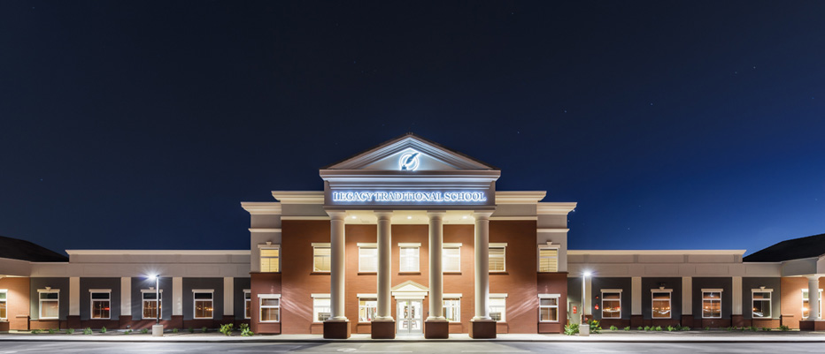

Charter schools received a 14% boost in state funding since 2008 and the money went into new land and buildings not in South Phoenix, Maryvale, or Safford but in Scottsdale, Gilbert, and Chandler. Charter holders have added $1,400,000,000 in new land, buildings and equipment since 2008. $1.4 billion. A Grand Canyon Institute study found that charters had over $2.6 billion in debt in the form of long-term leases and mortgages on new buildings in 2017.

Charter Land, Building, and Equipment Investments 2018 -2018
Year | 2008 | 2018 | Increase
Land and Land Improvements | $81,184,101 | $306,242,750 | $225,058,649
Building Improvements | $343,923,890 | $1,391,388,840 | $1,047,464,950
Site Improvements* | $18,654,070 | $15,968,319 | -$2,685,751
Equipment | $86,105,997 | $216,381,889 | $130,275,892
Building in progress | $18,253,886 | $40,820,937 | $22,567,051
Total | $529,467,874 | $1,954,834,416 | $1,422,680,791
Per pupil | $5,362 | $10,279
- Site improvement are the improvements made to leased facilities

School choice, in the form of charter schools, is very expensive. Every student that moved from a district school to a charter school in 2018 cost the state an additional $3,337/pupil in state education funds because districts receive an average of 44% of their revenue from local property taxes while charters receive all revenue from the state.

A rich district like Scottsdale Unified receives just 17% of their budget from the state, the rest comes from property taxes. A less effluent district, like Cartwright Elementary in west Phoenix, receives 56% of their funds from the state. Rural districts receive the most state funding because of low property values and the lack of business property. For example, Thatcher Elementary in Graham County, receives 79% of its funding from the state.

Charter schools, on the other hand, receive all of their funds from the state and none from property taxes. A student that moves from Scottsdale Unified ($1,788/pupil in state funds) to a charter school ($7,309/pupil) costs the state an additional $5,521/pupil.

Whether a charter is in Phoenix or in Prescott they receive the same basic state aide as district schools plus an additional $1,775/pupil for K-8 students and $2,068/pupil for students in grades 9-12 to cover the costs of facilities and capital expenses, since charters are unable to have bond elections to pay for these items. Instead of cutting these capital funds, like the legislature did for districts, the charter additional assistance has increased 23% since 2008.

Charter Additional Funding | Elementary | High School
2008 | $1,445 | $1,684
2018 | $1,775 | $2,068
% Increase | 22.8% | 22.8%

Additionally, when a student moves from a district school to a charter school, they leave behind an empty seat in a building the local taxpayers have already paid for. Now the state has to give the charter additional state funds to build another facility, except this one is owned by the charter holder, not the community.

Some charter owners have used increasing state funds to build schools and then sell them to non-profits they create for a huge profit…and keep control of the schools. The worst examples are:

- Leona Group owner Bill Coats sold 10 schools to his non-profit in 2007 for a $24 million profit. Coats still runs the schools through his charter management company (CMO).
- American Leadership Academy owner Glenn Way sold his schools to a non-profit he created for a $37 million profit. Way still runs the schools through his CMO.
- Republican Senator Eddie Farnsworth made $13.9 million selling his Benjamin Franklin Schools to his new non-profit. Farnsworth still runs the schools through his CMO.

Arizona has significantly shifted public education resources to charter schools, at the expense of public districts. The cost created by charter schools is staggering. If the 190,000 students in charter schools were still in public districts, the state would save over $3,000/pupil - $570,000,000 every year. That would pay for a $9,215 pay increase for Arizona’s 61,852 district and charter teachers.

Public district schools have far more at-risk and poor students than charter schools. District class size has increased dramatically since 2008. Poor teacher pay has eroded the number of qualified teachers in district classrooms and buildings are in disrepair.

Well -funded charter schools have small class sizes, new buildings, and far fewer of “those” students. Does anyone think this is a Republican “accident”?

Charter schools are here to stay in Arizona, no question. But other states limit the growth of charter schools by having strict rules on where and how many charters can be opened every year. Arizona Republicans, including the Governor, feel just the opposite - more charter schools provide greater school choice to their constituents in affluent suburbs while the public districts that educate all students are left struggling to educate at-risk kids, fix leaky roofs and are forced to watch hundreds of teachers leave the classroom for jobs that pay a living wage.

And Republicans in the Legislature again blocked any new charter oversight…

Just remember this: every new charter student in Arizona is taking over $3000 out of the state education fund that could be used to properly fund district schools. School choice is killing public education in Arizona.

Arizona’s teachers are among the lowest paid in the U.S. partly because Republicans have shifted state public education funds to charter schools since 2008. Red4Ed - don’t give up the fight to adequately fund public districts.

The Superintendents Annual Reports for 2008 and 2018 are at: http://www.azed.gov/superintendent/superintendents-annual-report/ 2008 district and charter data is on pages 46-47 of Volume I. 2018 district and charter data is on pages 37-38 of Volume I
Land and building data is on same pages as described in footnote 1
Curtis Cardine “Red Flags: Overleveraged Properties” at: http://grandcanyoninstitute.org/wp-content/uploads/2019/01/Red_Flags_Overleveraged_Properties_Jan_9_2019.pdf
Revenue data for all district and charter schools is in Volume II of the 2018 Superintendents Report. See footnote 1
Scottsdale Unified 2018 revenue is in Volume II p. I-130 of the 2018 Superintendents Report
2009 JBLC report: https://www.azleg.gov/jlbc/09recbk/adeform.pdf
Charters can lease facilities as well
See: The Leona Group profits by $25 million while schools spend the least in the classroom in AZ in the “Past Research” tab at azcsa.org
https://www.azcentral.com/story/news/local/arizona-education/2018/07/11/american-leadership-academy-charter-school-founder-glenn-way-nets-millions/664210002/
https://www.azcentral.com/story/news/local/arizona-education/2018/11/28/farnsworth-net-13-9-million-benjamin-franklin-charter-school-sale/2126183002/

