The Consequences of Unregulated Charter Schools:
Multi-National Charter Based in India Collects as Much in Profit as They Spend Operating Four Arizona Charter Schools

Pinnacle Education MGRM made $3.5 million profit from $6.9 million in tax revenues in 2016 – with only 620 students

Jim Hall
Arizonans for Charter School Accountability
March 6, 2017

Pinnacle Education MGRM is a wholly owned subsidiary of the multi-national software corporation WGRM based in India and owned by KVR Murthy. Pinnacle Education made over $3.4 million in profit last year owning and operating four charter schools in Arizona with a total enrollment of 620 students. One hundred percent of these profits came from the Arizona general fund. Table 1 below shows the expenditures in 2016 for the 4 Pinnacle MGRM schools:

Table 1 Pinnacle MGRM Annual Financial Report maintenance and operations expenditures (page 2)and revenue (page 1) 2016
Column1 | Pinnacle High School-Casa Grande | Pinnacle Education-Kino Academy, Inc. | Pinnacle Education-Tempe, Inc | Pinnacle Education-Westmark Chandler Boulevard, Inc | Total
Enrollment October 1 2015 | 40 | 105 | 431 | 44 | 620
1000 Instruction | $82,298 | $202,491 | $837,930 | $73,567 | $1,196,286
2100 Students | $18,227 | $70,758 | $546,981 | $11,786 | $647,752
2200 Instruction | $0 | $0 | $0 | $0 | 0
2300 General Administration | $10,333 | $20,405 | $222,957 | $11,395 | $265,090
2400 School Administration | $3,893 | $3,301 | $103,791 | $2,105 | $113,090
2500 Central Services | $867 | $29,831 | $285,218 | $881 | $316,797
2600 Operation & Maintenance of Plant | $62,685 | $93,181 | $403,300 | $65,109 | $624,275
2900 Other Support Services | $0 | $0 | $0 | $0 | $0
3000 Operation of Noninstructional Services | $0 | $0 | $0 | $0 | $0
4000 Facilities Acquisition & Construction | $0 | $0 | $0 | $0 | $0
5000 Debt Service | $0 | $0 | $0 | $0 | $0
610 School-Sponsored Cocurricular Activities | $0 | $0 | $0 | $0 | $0
620 School-Sponsored Athletics | $0 | $0 | $0 | $0 | $0
630, 700, 800, 900 Other Programs | $0 | $0 | $0 | $0 | $0
Subtotal (lines 1-14) | $178,303 | $419,967 | $2,400,177 | $164,843 | $3,163,290
200 Special Education
1000 Instruction | $175 | $1,207 | $118,073 | $2,049 | $121,504
2000 Support Services | $0 | $0 | $0 | $0 | $0
2100 Students
2200 Instruction | $0 | $0 | $0 | $0 | $0
2300 General Administration | $0 | $0 | $0 | $0 | $0
2400 School Administration | $0 | $0 | $0 | $0 | $0
2500 Central Services | $0 | $0 | $0 | $0 | $0
2600 Operation & Maintenance of Plant | $0 | $0 | $0 | $0 | $0
2900 Other Support Services | $0 | $0 | $0 | $0 | $0
3000 Operation of Noninstructional Services | $0 | $0 | $0 | $0 | $0
4000 Facilities Acquisition & Construction | $0 | $0 | $0 | $0 | $0
5000 Debt Service | $0 | $0 | $0 | $0 | $0
Subtotal (lines 16-26) | $175 | $1,207 | $118,073 | $2,049 | $121,504
300 Special Education Disability Title 8 PL 103-382 Add-On | $0 | $0 | $0 | $0 | $0
400 Pupil Transportation | $0 | $0 | $0 | $0 | $0
530 Dropout Prevention Programs | $0 | $0 | $0 | $0 | $0
540 Joint Career & Technical Ed. & Vocational Ed. Center | $0 | $0 | $0 | $0 | $0
550 K-3 Reading | $0 | $0 | $0 | $0 | $0
Subtotal (lines 15 and 27-32) | $178,478 | $421,174 | $2,518,250 | $166,892 | $3,284,794
Classroom Site Project (from page 4, line 14) | $12,430 | $22,462 | $118,450 | $5,498 | $158,840
Instructional Improvement Project (from page 5, line 5) | $1,582 | $4,093 | $35,553 | $1,529 | $42,757
Structured English Immersion Project (from page 6, line 14) | $0 | $0 | $0 | $0 | $0
Compensatory Instruction Project (from page 6, line 28 ) | $0 | $0 | $0 | $0 | $0
Federal and State Projects (from page 9, line 31) | $0 | $0 | $0 | $0 | $0
Total Expenditures | $192,490 | $447,729 | $2,672,253 | $173,919 | $3,486,391
Total Revenue | $308,516 | $738,033 | $5,671,435 | $242,678 | $6,960,662
Profit | $116,026 | $290,304 | $2,999,182 | $68,759 | $3,474,271

Pinnacle Education spent a total of $3,486,391 to operate the four schools and made $3,474,271 in profit. Note all of the zeroes above. They reflect all of the programs Pinnacle does not offer.

The Arizona State Board for Charter Schools is the only agency allowed by law to regulate Arizona charter schools. Here is the Charter Board’s financial assessment of Pinnacle Casa Grande:

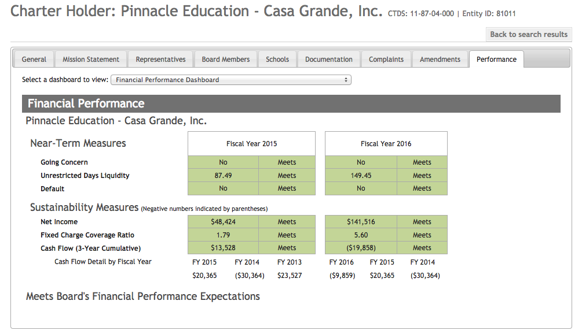

Pinnacle Education meets the requirements in every area evaluated by the Charter Board. The Charter Board is only concerned that the charter is a viable business. Pinnacle Education runs a business that generates as much profit as they spend. You can’t argue that’s not a great business. The question is: is it good business for the taxpayers of Arizona?

Pinnacle MGRM
MGRM (Multi-domain Global Relationship Management) provides products for dozens of industries including pharmaceuticals, insurance, automotive, medical, finance, government, construction, as well as education.
MGRM has one of the most unique corporate mission statements around as evidenced below: (The entire mission statement is in Appendix 1. There isn’t a corporate mission statement like it anywhere. It is worth reading).
MGRM's Research and Process based Technologies have the capability of efficiently and effectively addressing physical, psychological and social problems, setting Ultimate Rehabilitation as a process to achieve One World ... One Solution.
Pinnacle Education MGRM charter schools rely primarily on their software, MGRM’s M-Star – LSP, which provides learning management and courseware for grades 6-12. The Pinnacle Education schools receive 99% of their funding from the Arizona’s general fund and operate the schools with half of the money provided by the state. The other half is returned to MGRM corporate as profit.
How is it possible to only spend half of the available tax resources?
Pinnacle MGRM is not the only online charter company making outrageous profits in Arizona. ACSA recently reported that another for-profit online charter school, Primavera Online High School, made $10 million in profit in 2016 and paid a related firm $13 million in software licensing fees – out of a total budget of about $40 million. Online charter schools in Arizona receive 95% of the revenue regular charters receive for full-time students and 85% of revenue for part-time high school students. They receive the same charter add-on of $1700/pupil for K-8 and $2000/pupil for 9-12 as non-on line charter schools receive to pay for equipment and facilities.

These online schools have few expenses for facilities, teachers, and support staff. There is no transportation, cafeteria, nurse, librarian, music teacher, or art teacher. There a just a minimum number of teachers available to assist students as they navigate the computer instruction, often by email and telephone.

Online charter schools are funded at a much higher level than public districts. Arizona’s on-line schools receive 95% of the revenue of a regular charter school plus the additional charter add-on of $1700-$2000/pupil that public districts do not receive. Pinnacle Education MGRM and Primavera Online receive substantially more revenue from the state of Arizona than any public district, while providing just a fraction of the programs every comprehensive public district must provide. On-line charter schools are ridiculously over-funded – to the point that Pinnacle and Primavera can operate with half of the funds they receive, and reap the other half as profit.

Conclusions:
If the Arizona Auditor General were to release a report every year documenting the expenditures of charter schools, people would likely sit up and take notice when it is clear that on-line charter schools make tens of millions of dollars in profit every year. Arizona spending on public schools is among the lowest in the U.S. – every dollar is precious. But in Arizona, charter schools go largely unregulated to the point that, by law, the Auditor General cannot monitor charter schools spending.

But Arizonans for Charter School Accountability does monitor charter spending, collecting the data from all 411 charter holders’ 2016 annual financial reports, the same report the Auditor General uses to monitor public districts. The data are shocking. Waste, fraud and abuse are rampant in Arizona Charter schools. Pinnacle Education MGRM is a perfect example.

Recommendations:
- Arizonans need to demand that the Arizona Auditor General monitor charter school spending.
- The Arizona Legislature needs to revise the funding formula for online schools. They cost much less to operate and the savings are going straight to corporate profits.
- The Arizona State Board for Charter Schools needs to step up and sanction charter holders that misuse tax funds for personal gain.

Appendix
The MGRM corporate mission statement found at: http://www.mgrm.com/
“MGRM (Multi-domain Global Relationship Management), recognizes the urgent need for an absolute commitment towards achieving this goal in order to conserve our society for the future generations. MGRM believes that the root cause of the problems inflicting the modern society are the negative forces existing within individuals and it is the individuals that should be addressed in all the dimensions to overcome problems. MGRM's Research and Process based Technologies have the capability of efficiently and effectively addressing physical, psychological and social problems, setting Ultimate Rehabilitation as a process to achieve One World ... One Solution.
All beings on this planet – plants, animals, etc., except humans – are able to have harmony in their lives during their existence. The lack of harmony in humans, within themselves, amongst themselves and with nature, has lead to several problems faced by humanity – terrorism, poverty, crime, aids, war, etc.
It is important and necessary to bring back harmony into human lives in the three dimensions – physical, psychological and social, which will lead them to the 4th dimension evolving as “spiritual” entities, at peace with themselves, amongst themselves and with nature. This will enable humans to evolve from “Individuals to Complete Personalities”.
MGRM specializes in recognizing the physical, psychological and social needs, rather than wants, of a person at every stage of the Human Life Cycle and addressing them through a variety of applications, tools, services and products.
All MGRM Group Companies are committed towards the vision of "Ultimate Rehabilitation of the Human Race", and the mission "To make an individual, a Complete Personality".

The full report on Primavera Online is at azcsa.org
A.R.S. 15-808. Arizona online instruction; reports; definitions at http://www.azleg.gov/ars/15/00808.htm
See our website for all reports on charter school classroom spending for 2016 at azcsa.org

