Millions Are Wasted When Charter Owners Don’t Follow Procurement Laws
Arizonans for Charter School Accountability

The problem with charter schools not following procurement rules is far more pervasive than one-time sell offs that enrich owners, like the $13.9 million payday Republican Eddie Farnsworth had last year selling his schools buildings. When charter owners don’t have to gets bids for purchases or have their expenditures approved by school boards in public meetings, it opens the door to “self-dealing” - in essence buying goods and services from yourself at an unknown markup. The accounting term is “related party transactions”.

The following are charter schools that exemplify the self-dealing that is costing taxpayers millions every year and enriching charter owners. (The statements in italics are taken directly from the last available audit required of all charter schools)

Imagine Avondale Elementary
Imagine schools are run by the national chain Imagine Inc. and are masters at self-dealing. The 20 Imagine schools have individual charters but turn over all aspects of school operations to the parent company. All decisions about the schools then take place in secret at the corporate level, not with each school’s governing board. These 2018 expenditures are from Imagine Avondale Elementary and are typical of all 20 Imagine schools:

1. Imagine Avondale Elementary turns over all operations to the related party Imagine Inc. that hires all employees, provides management, and leases all facilities to the schools through their for-profit real estate company SchoolHouse Financial LLC (at an unknown markup):

“The School is related to Imagine Schools, Inc. by virtue of an operating agreement and common management. All personnel utilized by the School are employees of Imagine Schools, Inc. The School reimburses Imagine Schools, Inc. for actual payroll costs and benefits. For the year ended June 30, 2018, payroll, taxes and benefits paid to Imagine Schools, Inc. totaled $2,728,347”.
“Imagine Schools, Inc. is responsible for organizing, developing, managing and staffing the School. For the year ended June 30, 2018, fees were paid to Imagine Schools, Inc. based upon 12% of the School's state revenues and totaled $389,397”.
“The School has a facility lease for classrooms and administrative offices…The agreement is with a leasing company that is a related party due to its affiliation with Imagine Schools, Inc. (see Note 7). Lease expense for the year ended June 30, 2018 was $1,069,390”.
2. Imagine Inc. sells itself insurance called “loss mitigation” in case the school loses money (pretty likely - Imagine schools overspent their revenue by $5 million last year). No other charter owner in the state pays themselves a percentage of revenue for insurance against their own mismanagement.

“The School participates in a loss mitigation program with Imagine Schools, Inc., whereby it pays a fee of 1% of the School's state revenues in order to receive forgiveness of a certain percentage of operating advances from Imagine Schools, Inc. For the year ended June 30, 2018, the fee totaled $32,450. “

3. Imagine “loans” each school start-up funds when they first open. Imagine Inc. loaned themselves $250,406 at 10.5% interest in 2008 when Avondale Elementary was founded. Over the 20-year period of the loan, Imagine Inc. will have paid themselves $30,000 every year for a total of $600,000 to repay the loan – all with tax funds.

“During the year ended June 30, 2008, the School borrowed $250,406 from Imagine Schools, Inc. for start-up costs. The note bears interest at 10.50% per annum, and matures in July 2028. Principal and interest payments of $2,500 are due monthly.”

4. Imagine Inc. is a national company with small town nepotism. Family members of Imagine Inc. executives get special perks:
- “A relative of the Executive Vice President was contracted to perform grant writing services. During the year ended June 30, 2018, the School paid $11,200 for these services”.
- “A relative of the Regional Director was contracted to perform psychology services. During the year ended June 30, 2018, the School paid $24,915 for these services”.
All of these activities would be illegal if sanctioned by a district school board.

Southgate Academy: small charter – big real estate deals
Self-dealing is commonplace in small Arizona charter schools as well. This is a real estate deal made between Southgate Academy (enrollment 469 students) in Tucson and a real estate firm run by one of the charter’s owners:
NOTE 10 RELATED PARTY TRANSACTIONS (2017 audit)
A Southgate board member, who is also a member of management, has an ownership interest in Millennium Community Ventures, LLC (MCV). MCV is also a member of Pyramid Ventures, LLC (Pyramid). Southgate made interest payments of $48,000 to Pyramid via a member during the fiscal year ending June 30, 2017. Southgate had an amount outstanding $2,481,706 to Pyramid for principal payments on a note for land purchased and originally valued at $4,000,000 and with the intention to expand the school facilities. During the year ended June 30, 2017, it was determined that Southgate would not be able to use the land to expand and they were unable to sell the land. As a result, the land was turned over to Pyramid and the remaining debt was forgiven.

Southgate bought a piece of undeveloped desert outside of Tucson (see photo below) in a “wraparound” deal where they paid the purchase price of $967,770 to Land America Title Company over a two-year period leaving $3,174,028 owed to Pyramid Ventures LLC, partly owned by Southgate board member Sheryl Matyjasik. Southgate made payments to Pyramid totaling $695,000 from 2012-2017. In 2017 Southgate decided they didn’t need the land and claimed they couldn’t find a buyer willing to pay the $2,481,706 owed to Pyramid (there is no evidence that the property was ever listed). The school simply gave the property back to Pyramid Ventures. Sheryl Matyjasik now owns a $ 1 million property (worth $ 4 million?) paid for by her school (Arizona taxpayers) and pocketed an additional $695,000. The Arizona State Board for Charter Schools reviewed the Southgate audit and found no problems.
Red dot - Undeveloped desert property at 3580 West Valencia Tucson, AZ bought by Southgate Academy for $4,000,000 (Google Maps)
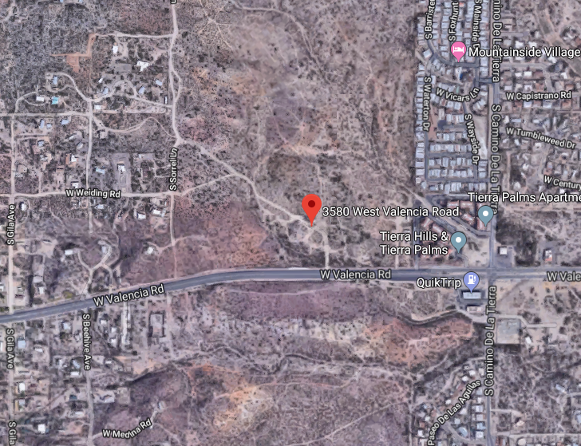

On top of that…
One of the members of Pyramid Ventures is as a member of 4 Diamond Builders, LLC. Southgate paid $1,442,626 to 4 Diamond Builders for construction services.
4 Diamond Builders, owned by Sheryl Matyjasik’s business partner Jeff Sharifi, have been paid $2,902,912 by Southgate Academy for construction work since 2012, without bids.
Management and real estate:
186 charters have related party management companies – owners of dozens of small charters form management companies and pay themselves to “manage” the school. Many charters lease their facilities from companies owned by the charter holder –all for an unknown markup.
Research Based Education Corp. has 97 students and has related party transactions with two separate companies for building leases and management :
- The School's governing board is comprised of three individuals that are members in other related party companies. The board members hold equal shares of Big Chino Holdings, L.L.C., which rents facilities to the School. Two of the three governing board members hold an equal share of Edvantage Partners, L.L.C., with the third board member being employed by Edvantage Partners, L.L.C. One board member is the single member of JBS Educational Services, L.L.C., which provides professional services to the School.
- The School leases facilites from a related party, Big Chino Holdings, L.L.C., under the provisions of a lease agreement classified as an operating lease for accounting purposes. Rent expense under the lease agreements consisted of the following for the years ended June 30: 2018 $160,500, 2017 $140,388, 2016 $48,200
- During the years ended June 30, 2018, 2017, and 2016, the School hired EdVantage Partners, L.L.C. through competitive bidding to perform contracted services in the following areas: (1) attendance reporting services; (2) administrative support services; (3) business and financial services; and (4) special educational services. In addition, EdVantage Partners, L.L.C. purchased supplies and other miscellaneous items on behalf of the School. The combined fees for those services totaled $32,196, $30,966, and $32,588, respectively. As of June 30, 2018 and 2017, the School had reimbursed Edvantage Partners, L.L.C. $57,329 and $3,733, respectively, which left $2,100 and $27,233, respectively, outstanding as accounts payable to related parties. As of June 30, 2016, the School had paid the entire amount owed to EdVantage Partners, L.L.C.

All this for 97 students…really?

Self-dealing takes on many other forms:
- GAR LLC helped the owner’s son sell his car:
“During the year ending June 30, 2018, the School purchased a vehicle from the son of a member for $16,500”.
- American Basic Schools board members formed SafeTrans LLC to maintain their buses but their auditor found they overpaid themselves $157,740 for services they didn’t receive in 2016:
“The School is related to SafeTrans, LLC (ST) through common members and management. During the year ended June 30, 2016, the School and HV entered into an agreement with ST, where ST would provide repairs and maintenance on buses utilized by the schools. At June 30, 2017, the School recorded $157,740 as part of due from related party as a result of the School's payments to ST exceeding the services provided. During the year ended June 30, 2018, the School incurred $151,807 of expenses related to these services, and repaid, or paid directly to a 3rd party vendor, $104,561. The remaining credit balance of $204,986 is included in due from related party on the statement of financial position at June 30, 2018”.
Paying yourself $157,000 for services that were not provided sure looks like a red flag that should trigger a full audit by the state, but the Charter Board did nothing. In fact, no charter owner has ever been audited by a state agency since 1996.

Thank goodness the auditors report all of this self-dealing – or do they?
One of the biggest charter paydays came this year when Glenn Way, owner of American Leadership Academies (ALA), sold the schools owned by his real estate company to the charter school for a $18 million profit. Unfortunately, ALA’s auditor, Joel D. Huber, never revealed that Way’s real estate company, Schoolhouse Development LLC, was renting the schools to ALA for $8 million/year. The 2017 audit simply stated:
NOTE 8 – RENT
The school rents buildings and property. For the fiscal year ending June 30, 2017 total rent paid was $8,726,554.
There is no mention of any related party transactions at all in the audit. In fact, Mr. Huber failed to disclose Glenn Way’s self-dealing since 2012. We have filed formal complaints against Joel D. Huber with the Arizona State Board of Accountancy and they are investigating the charges. If this auditor can ignore $8 million in related party transactions, how many other self-dealing schemes are out there we know nothing about?

Charter owners should not be able to use tax funds as a personal checkbook. The Legislature must require charter owners to follow procurement laws and the Arizona State Board for Charter Schools must be given the authority to audit charters making inappropriate expenditures of tax funds. There are red flags everywhere…

https://www.azcentral.com/story/news/local/arizona-education/2018/11/28/farnsworth-net-13-9-million-benjamin-franklin-charter-school-sale/2126183002/
All audit data can be found for each charter at: https://online.asbcs.az.gov/charterholders/search/results?corporate_name=&entity_id=&ctds=
See azcsa.org “Past Research” for a full report on Imagine Inc.
See azcsa.org “Past Research” for a complete report on American Leadership Academies
https://www.azcentral.com/story/news/local/arizona-education/2018/07/11/american-leadership-academy-charter-school-founder-glenn-way-nets-millions/664210002/

