The Worst Charter Schools in Arizona 2017 – Part 1
The Charter Board’s five “Best Performers” are among the worst schools in the state

Jim Hall
Arizonans for Charter School Accountability

The Arizona Republic March 1, 2018 article “Dozens of Arizona charter schools are at risk of closing due to financial woes” by Agnel Philip and Ricardo Cano revealed that 40 charter schools are in serious financial difficulty and could be in danger of closing.
The authors listed the five “top performers” according to the Charter Board - charter holders that had the most days of financial reserves and met all the Arizona State Board for Charter Schools’ financial standards:
Deer Valley Charter School
AIBT Charter School
Educational Options Foundation,
Kestrel Schools
James Sandoval Prep

The Charter Board did not examine how these charter owners came to be so flush with cash. While the five charters are certainly not in danger of closing, they are among the worst examples in the state of charter owners misusing of public funds.
Here is how the “top performers” actually spent your tax dollars:
Deer Valley Charter School
The Charter Board concurred that Deer Valley Charter School (DVCS) is a “top performer” and renewed their charter for an additional 20 years in 2015. Instead, it is one of the most wasteful schools in Arizona. DVCS had only 18 students in 2017 and has had an average enrollment of 23 students since 2012. It costs taxpayer over $30,000/pupil ($35,297 in 2017) to operate DVCS. While enrollment has been stagnant since 2012, administrative costs have doubled to over $200,000/ year. The director of the school, Barbara Dalicandro, made $97,000 last year while total teacher salaries were $149,000. DVCS owners have amassed over $1 million in cash assets…serving 23 students a year.
Deer Valley Academy’s enrollment reported on the annual October 1 Enrollment Report and in the Superintendent’s Annual Report ranged from 18 to 29 students 2012-2017. The school was funded based on an average daily membership between 80 to 90 students since 2012. We have no idea which enrollment data is accurate. We do know that only 11 students took the 2017 AZ Merit math test and only 2 passed.
Public school critics constantly complain that there should be consolidation of Phoenix elementary schools to save tax funds. Over half of all Arizona charter schools have less than 300 students. In the charter world, ridiculously small schools are allowed (and encouraged), wasting millions each year. DVCS is a perfect example.
Schools owned by Steven F. Durand II

Amazingly, the other four “top performing” charter schools are all owned by Steven F. Durand II. Mr. Durand’s four schools brought in $8,966,591 in 2017 but he only spent half of that ($4,547,311) running the schools. The rest went into the bank where Mr. Durand’s non-profit has amassed over $16 million in cash assets since 2012.

Only 11% of the schools’ revenue found its way into the classroom since 2012 and administrative spending exceeded classroom spending by over $2.7 million over that time period.

How is it possible to run a school spending half of its revenue? Two words: Online instruction.

For example, EdOptions High School is located in a large room full of computers at 2150 E Southern. Kestrel Schools (Valley Prep Academy) is also located at 2150 E Southern in a large room of computers. Why have two separate charters in one building? Simple - to make more money.

EdOptions also has 13 “Learning Centers” in metro Phoenix, Nogales, Alpine, Quartzsite, Cottonwood, Prescott, and Prescott Valley. Despite having 15 locations, EdOptions and Kestrel Schools had combined classroom expenditures (teacher and teacher aid salaries, benefits and instructional supplies) of just $368,000, out of a total budget of $5,747,000. Administrative costs for the two schools were nearly three times as much - over $981,000.

The four schools owned by Mr. Durand expended $785,000 more on administration than in the classroom just in 2017. Since 2012, Durand’s schools have spent $2.7 million more on administration than in the classroom…and put $16 million in the bank.

Mr. Durand has been using the $16 million to buy real estate in cash transactions:
- 7033 W Cactus Rd. - a large church property purchased 1/28/2016 for $1,1300,00
- 67th Ave. and Avenida del Sol - a vacant lot bought 2/1/2017 for $200,000
- 6710 W. Calle Lejos, a 5500 square foot house with a six-car garage purchased 3/29/17 for $1,350,000. (See below)

6710 W. Calle Lejos Peoria, AZ purchased for $1.35 million cash by the Educational Options Foundation in 2017

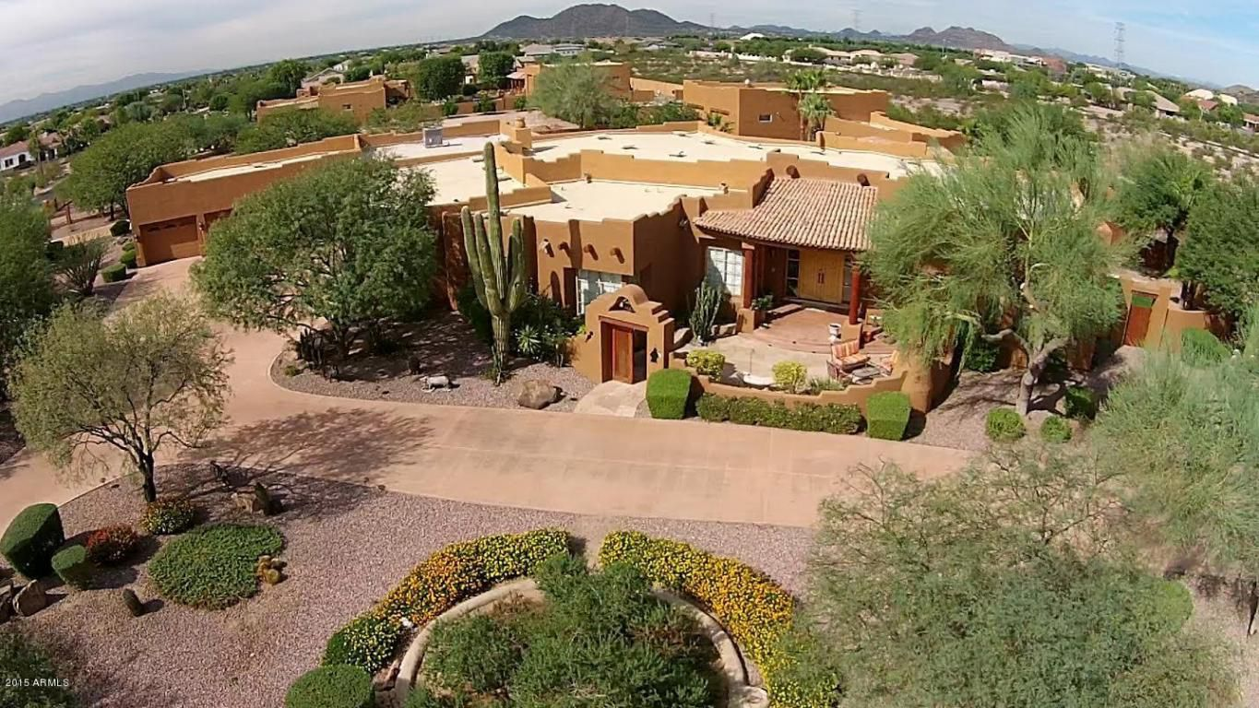

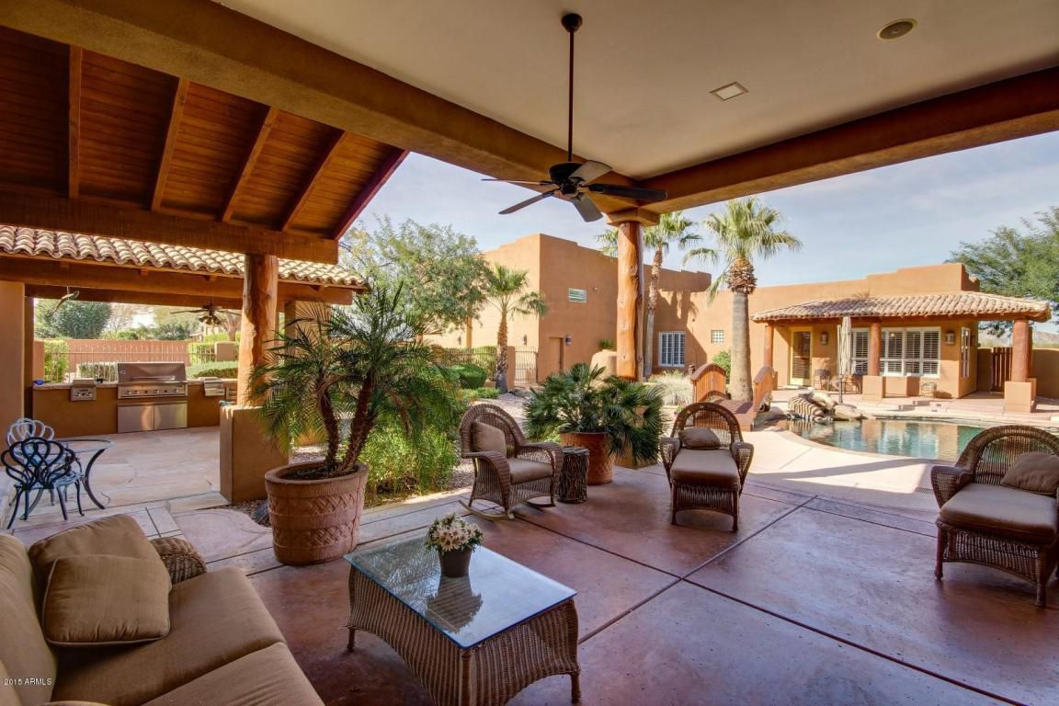

The state of Arizona paid for this luxury estate and the Charter Board asked no questions – Kestrel and James Sandoval were renewed for 20 years in 2015.

The failure of the Charter Board to review charter spending is allowing waste and fraud on a massive scale. If these are the top five financial performing charter schools in Arizona, imagine what untold horror stories await us if the Auditor general was ever allowed to monitor charter schools.

The Charter Board’s Financial Framework does absolutely nothing to protect taxpayers from the waste of public funds. Their “top performing” schools make that quite clear.

